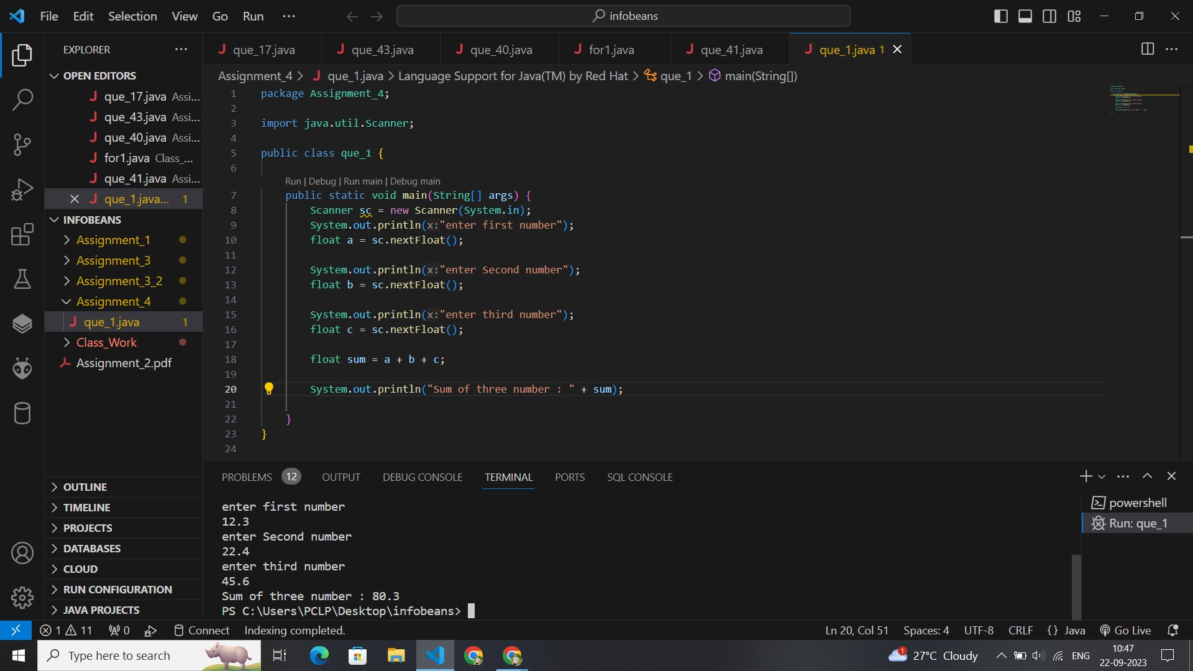

// package Assignment_4;

import java.util.Scanner;

public class que_1 {

    public static void main(String[] args) {

        Scanner sc = new Scanner(System.in);

        System.out.println("enter first number");

        float a = sc.nextFloat();

        System.out.println("enter Second number");

        float b = sc.nextFloat();

        System.out.println("enter third number");

        float c = sc.nextFloat();

        float sum = a + b + c;

        System.out.println("Sum of three number : " + sum);

    }

}

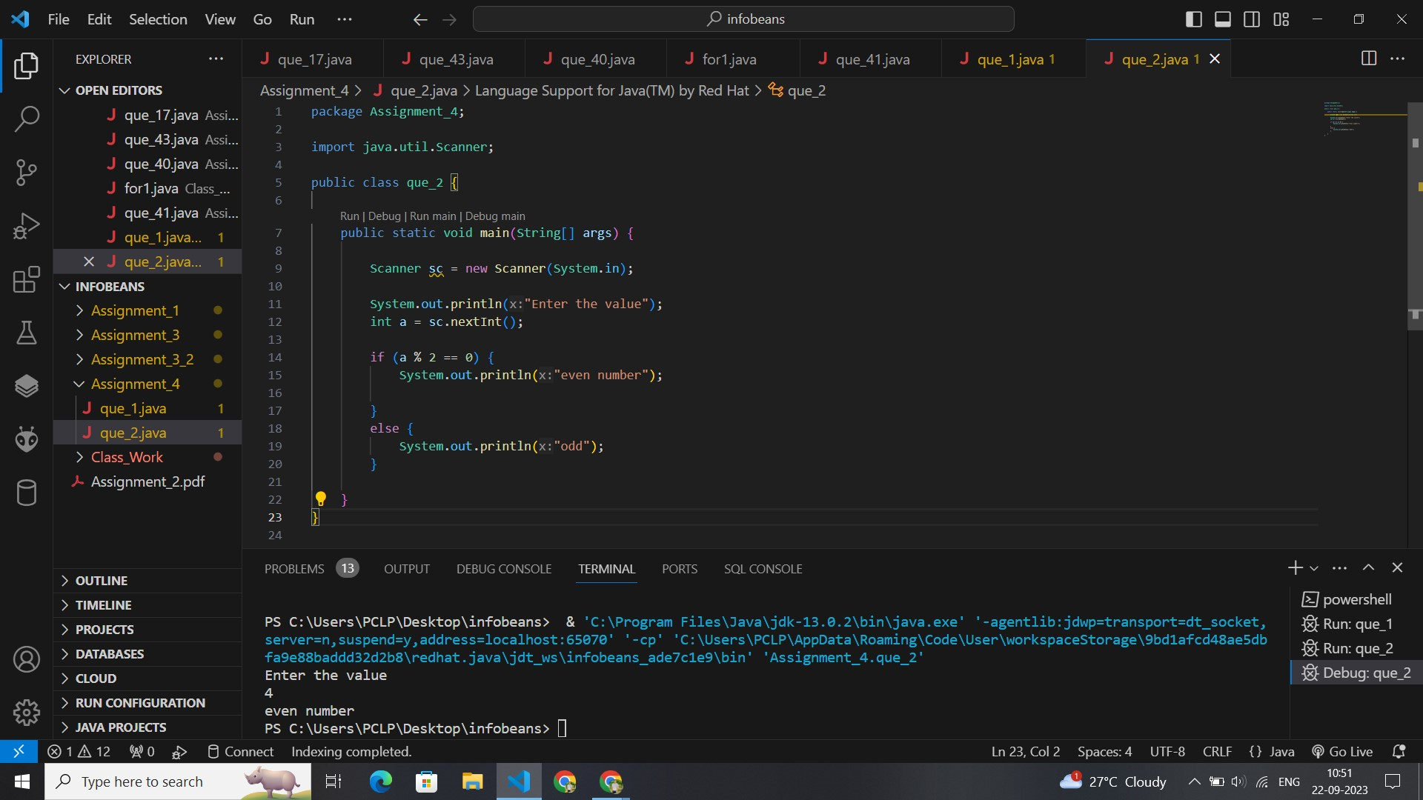

// package Assignment_4;

import java.util.Scanner;

public class que_2 {

    public static void main(String[] args) {

        Scanner sc = new Scanner(System.in);

        System.out.println("Enter the value");

        int a = sc.nextInt();

        if (a % 2 == 0) {

            System.out.println("even number");

        } else {

            System.out.println("odd");

        }

    }

}

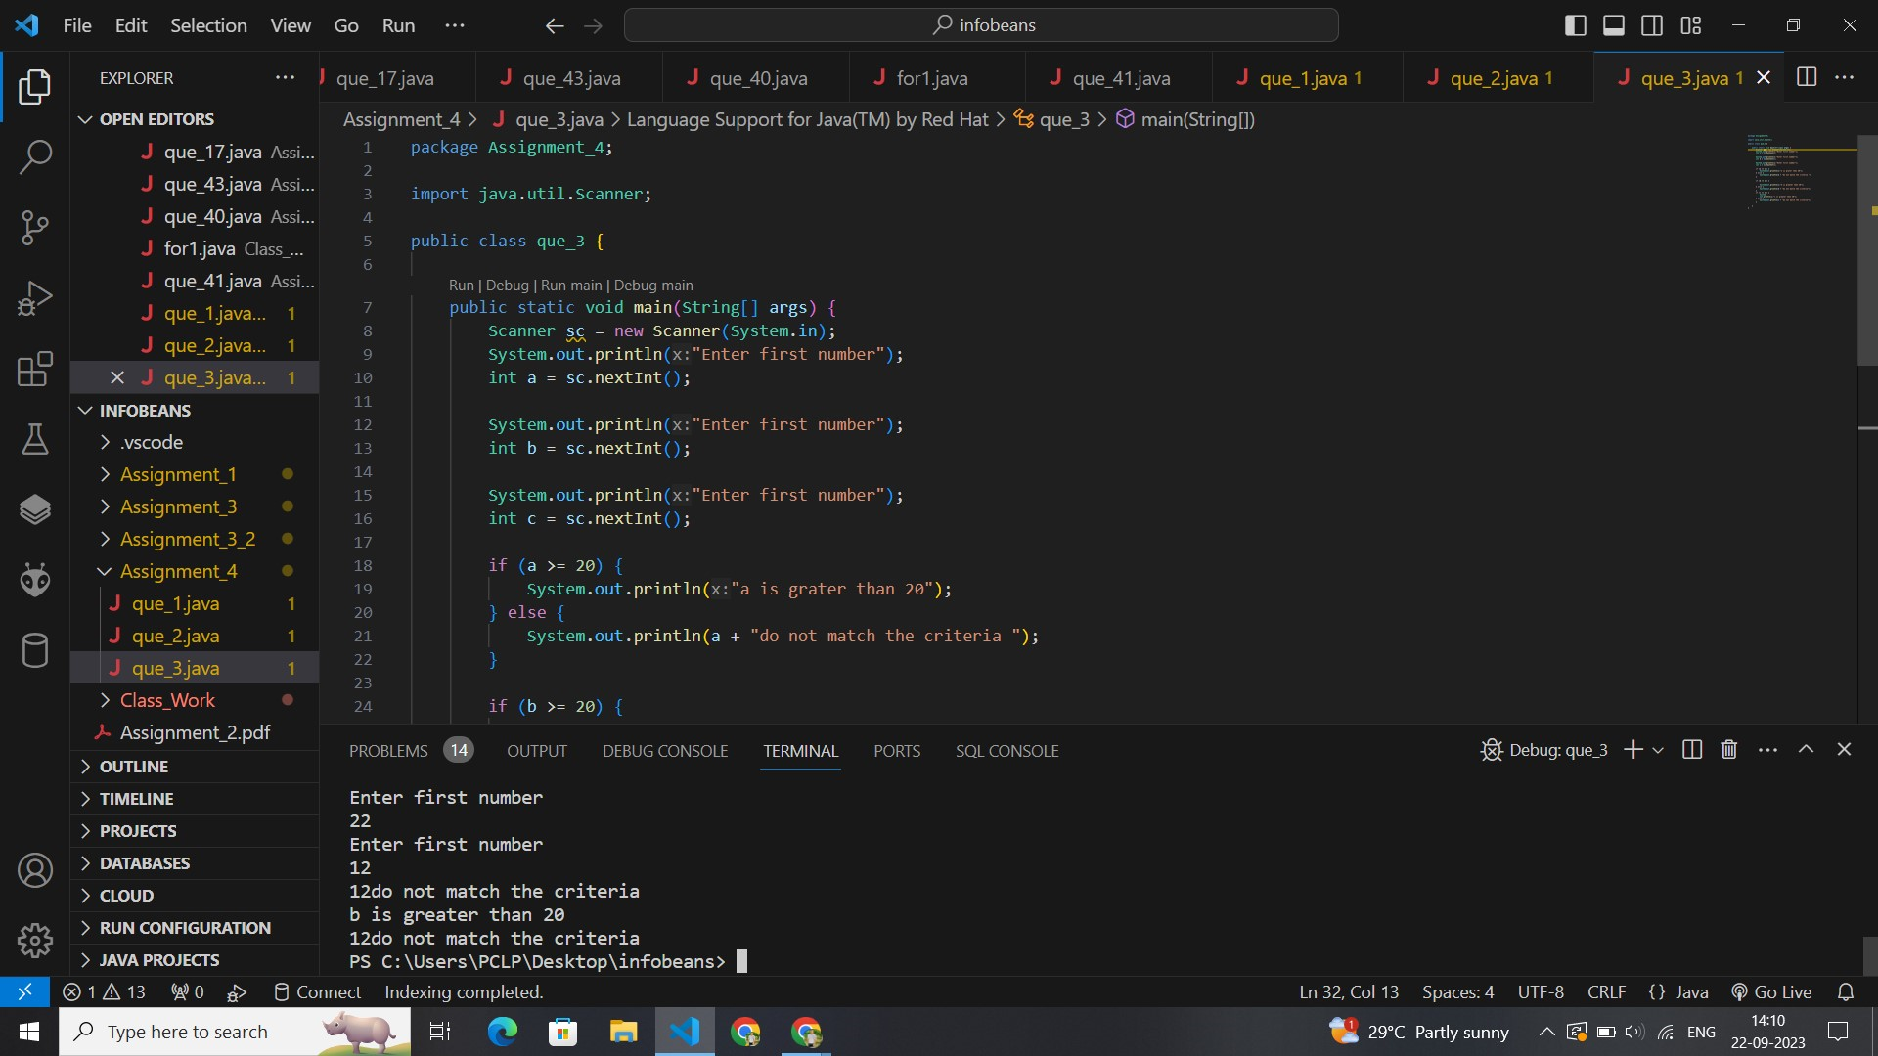// package Assignment_4;

import java.util.Scanner;

public class que_3 {

    public static void main(String[] args) {

        Scanner sc = new Scanner(System.in);

        System.out.println("Enter first number");

        int a = sc.nextInt();

        System.out.println("Enter first number");

        int b = sc.nextInt();

        System.out.println("Enter first number");

        int c = sc.nextInt();

        if (a >= 20)

        {

            System.out.println("a is grater than 20");

        } else {

            System.out.println(a + " do not match the criteria ");

        }

        if (b >= 20) {

            System.out.println("b is greater than 20");

        } else {

            System.out.println(b + " do not match the criteria");

        }

        if (c >= 20) {

            System.

            out.println("c is greater than 20");

        } else {

            System.out.println(c + " do not match the criteria");

    }

}

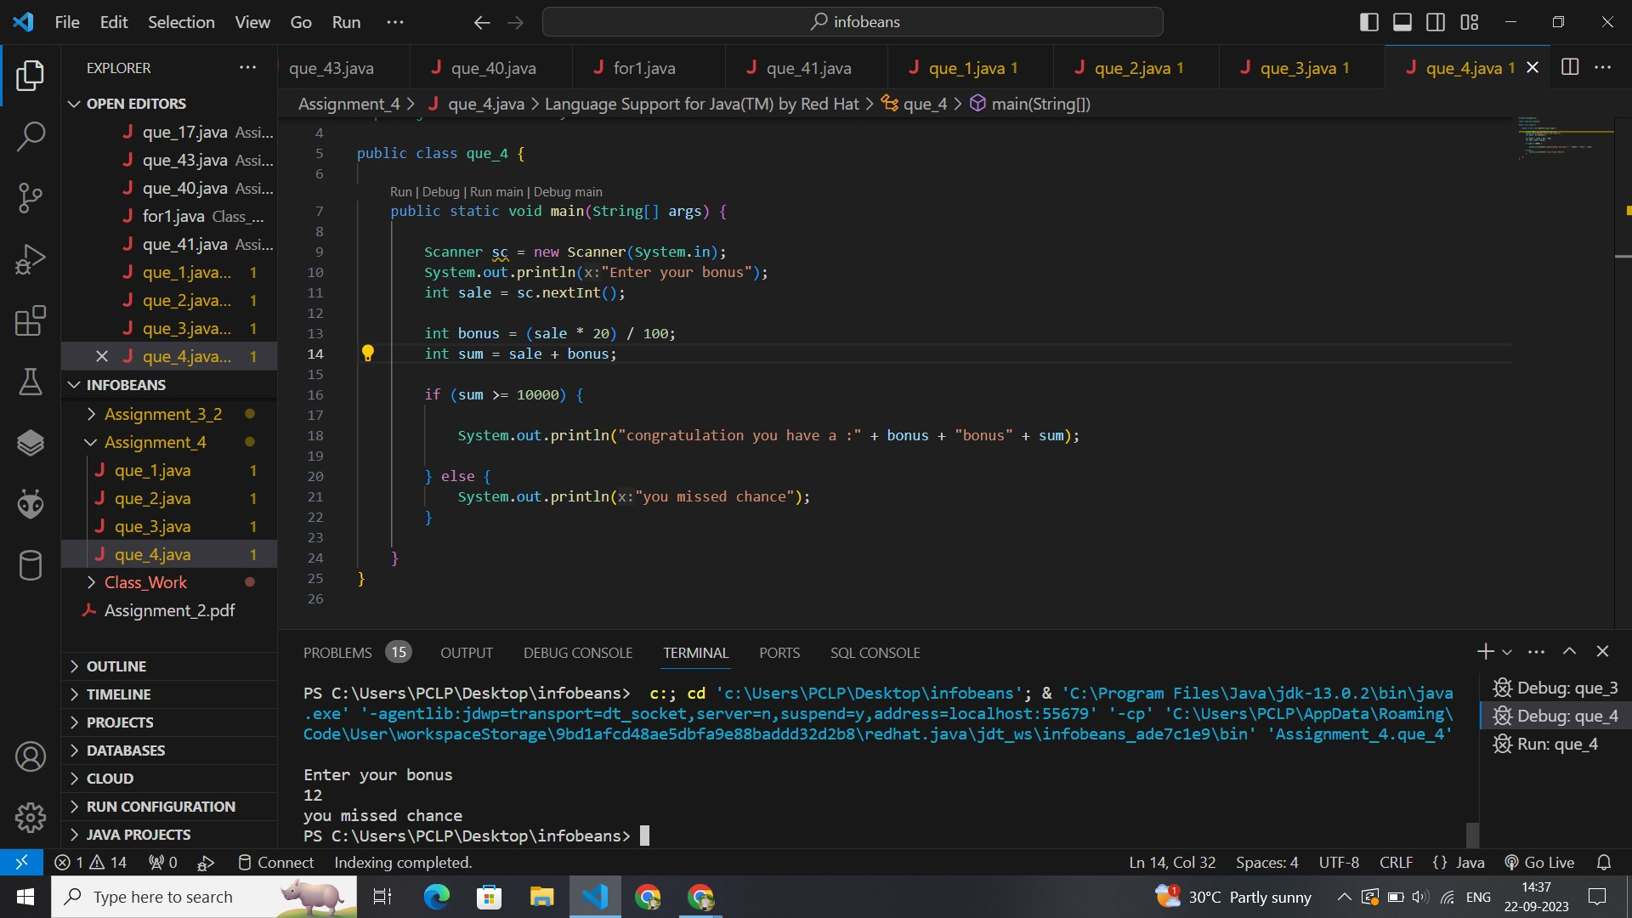// package Assignment_4;

import java.util.Scanner;

public class que_4 {

    public static void main(String[] args) {

        Scanner sc = new Scanner(System.in);

        System.out.println("Enter your bonus");

        int sale = sc.nextInt();

        int bonus = (sale * 20) / 100;

        int sum = sale + bonus;

        if (sum >= 10000) {

            System.out.println("congratulation you have a : " + bonus + " bonus " + sum);

        } else {

            System.out.println("you missed chance");

        }

    }

}

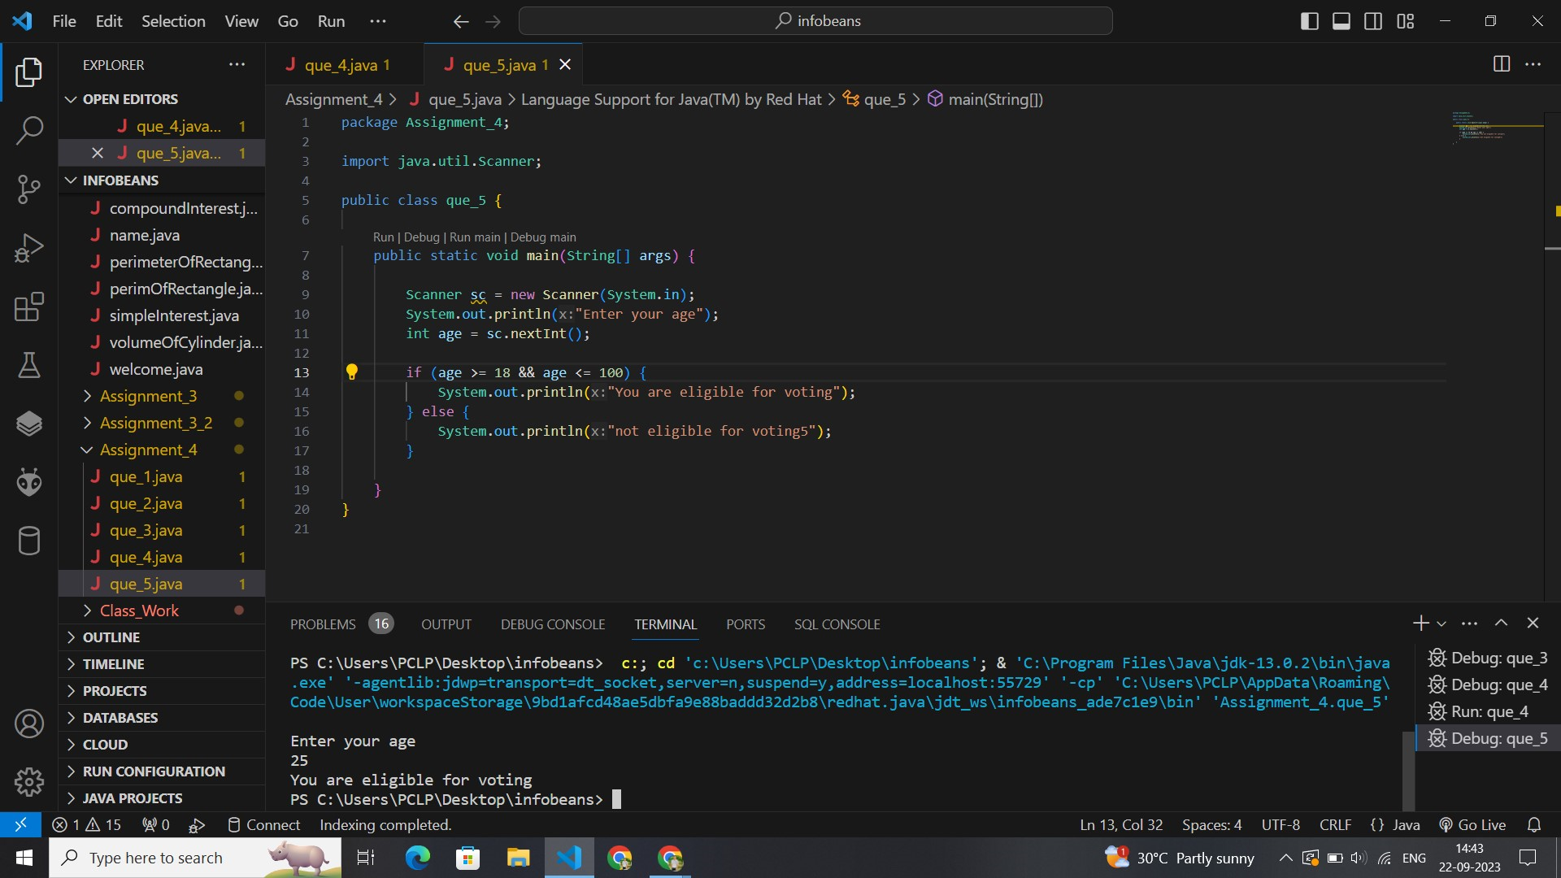package Assignment_4;

import java.util.Scanner;

public class que_5 {

    public static void main(String[] args) {

        Scanner sc = new Scanner(System.in);

        System.out.println("Enter your age");

        int age = sc.nextInt();

        if (age >= 18 && age <= 100) {

            System.out.println("You are eligible for voting");

        } else {

            System.out.println("not eligible for voting5");

        }

    }

}

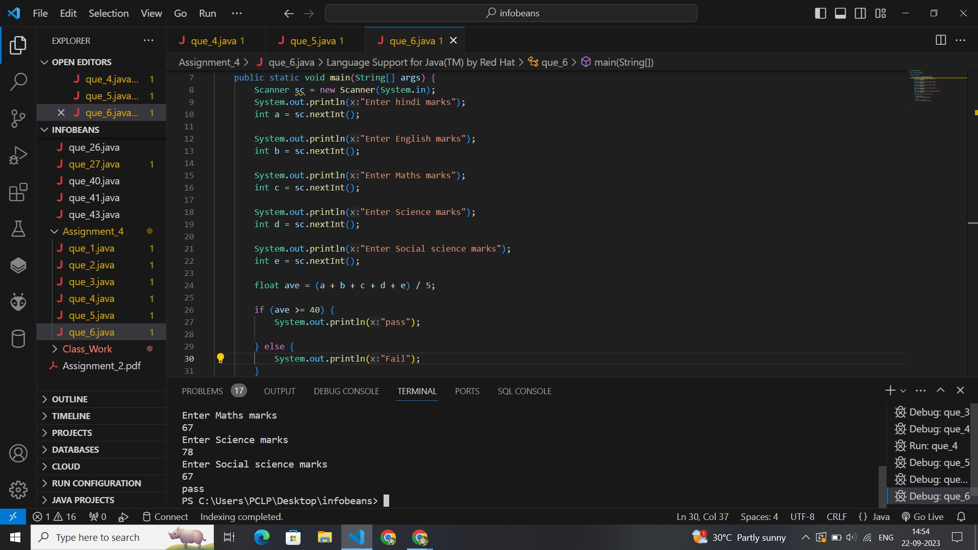// package Assignment_4;

import java.util.Scanner;

public class que_6 {

    public static void main(String[] args) {

        Scanner sc = new Scanner(System.in);

        System.out.println("Enter hindi marks");

        int a = sc.nextInt();

        System.out.println("Enter English marks");

        int b = sc.nextInt();

        System.out.println("Enter Maths marks");

        int c = sc.nextInt();

        System.out.println("Enter Science marks");

        int d = sc.nextInt();

        System.out.println("Enter Social science marks");

        int e = sc.nextInt();

        float ave = (a + b + c + d + e) / 5;

        if (ave >= 40) {

            System.out.println("pass");

        } else {

            System.out.println("Fail");

        }

    }

}

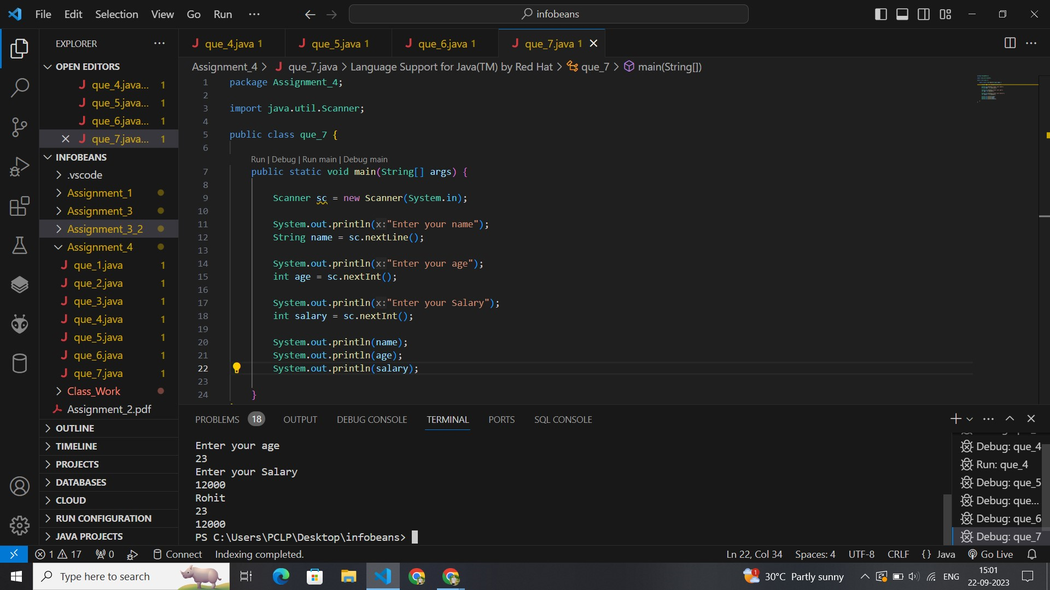

package Assignment_4;

import java.util.Scanner;

public class que_7 {

    public static void main(String[] args) {

        Scanner sc = new Scanner(System.in);

        System.out.println("Enter your name");

        String name = sc.nextLine();

        System.out.println("Enter your age");

        int age = sc.nextInt();

        System.out.println("Enter your Salary");

        int salary = sc.nextInt();

        System.out.println(name);

        System.out.println(age);

        System.out.println(salary);

    }

}

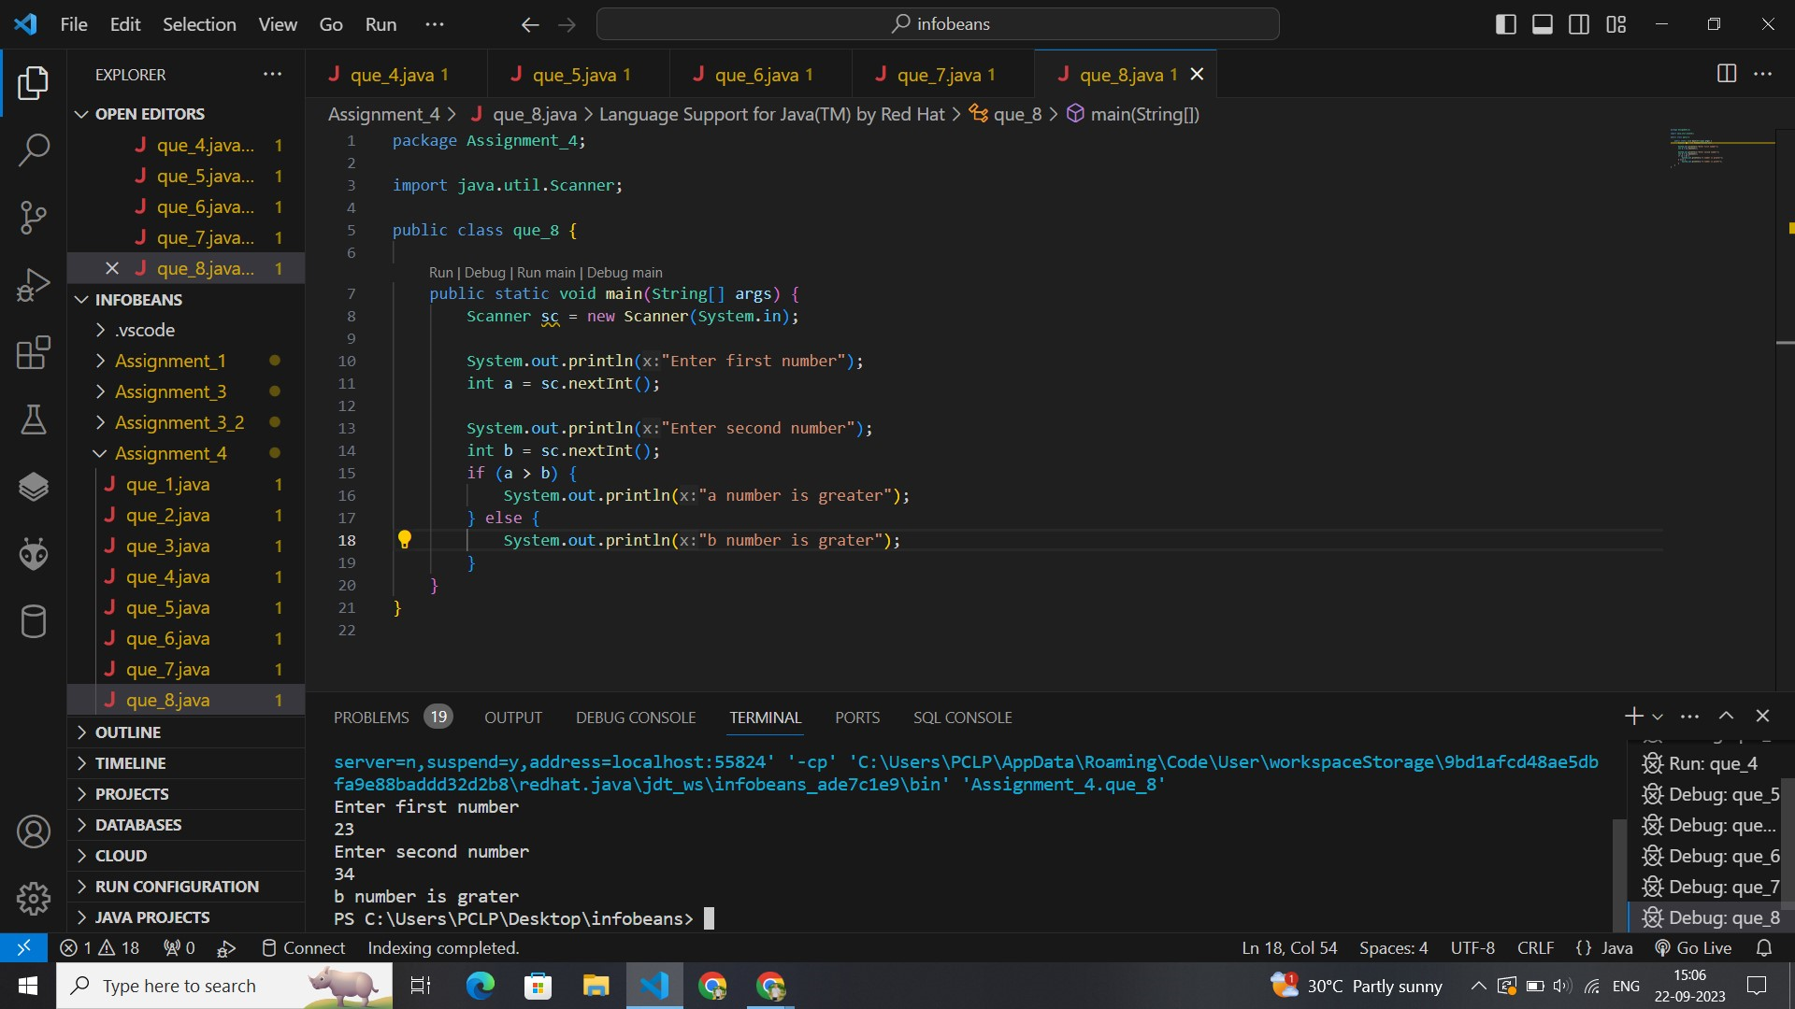package Assignment_4;

import java.util.Scanner;

public class que_8 {

    public static void main(String[] args) {

        Scanner sc = new Scanner(System.in);

        System.out.println("Enter first number");

        int a = sc.nextInt();

        System.out.println("Enter second number");

        int b = sc.nextInt();

        if (a > b) {

            System.out.println("a number is greater");

        } else {

            System.out.println("b number is grater");

        }

    }

}

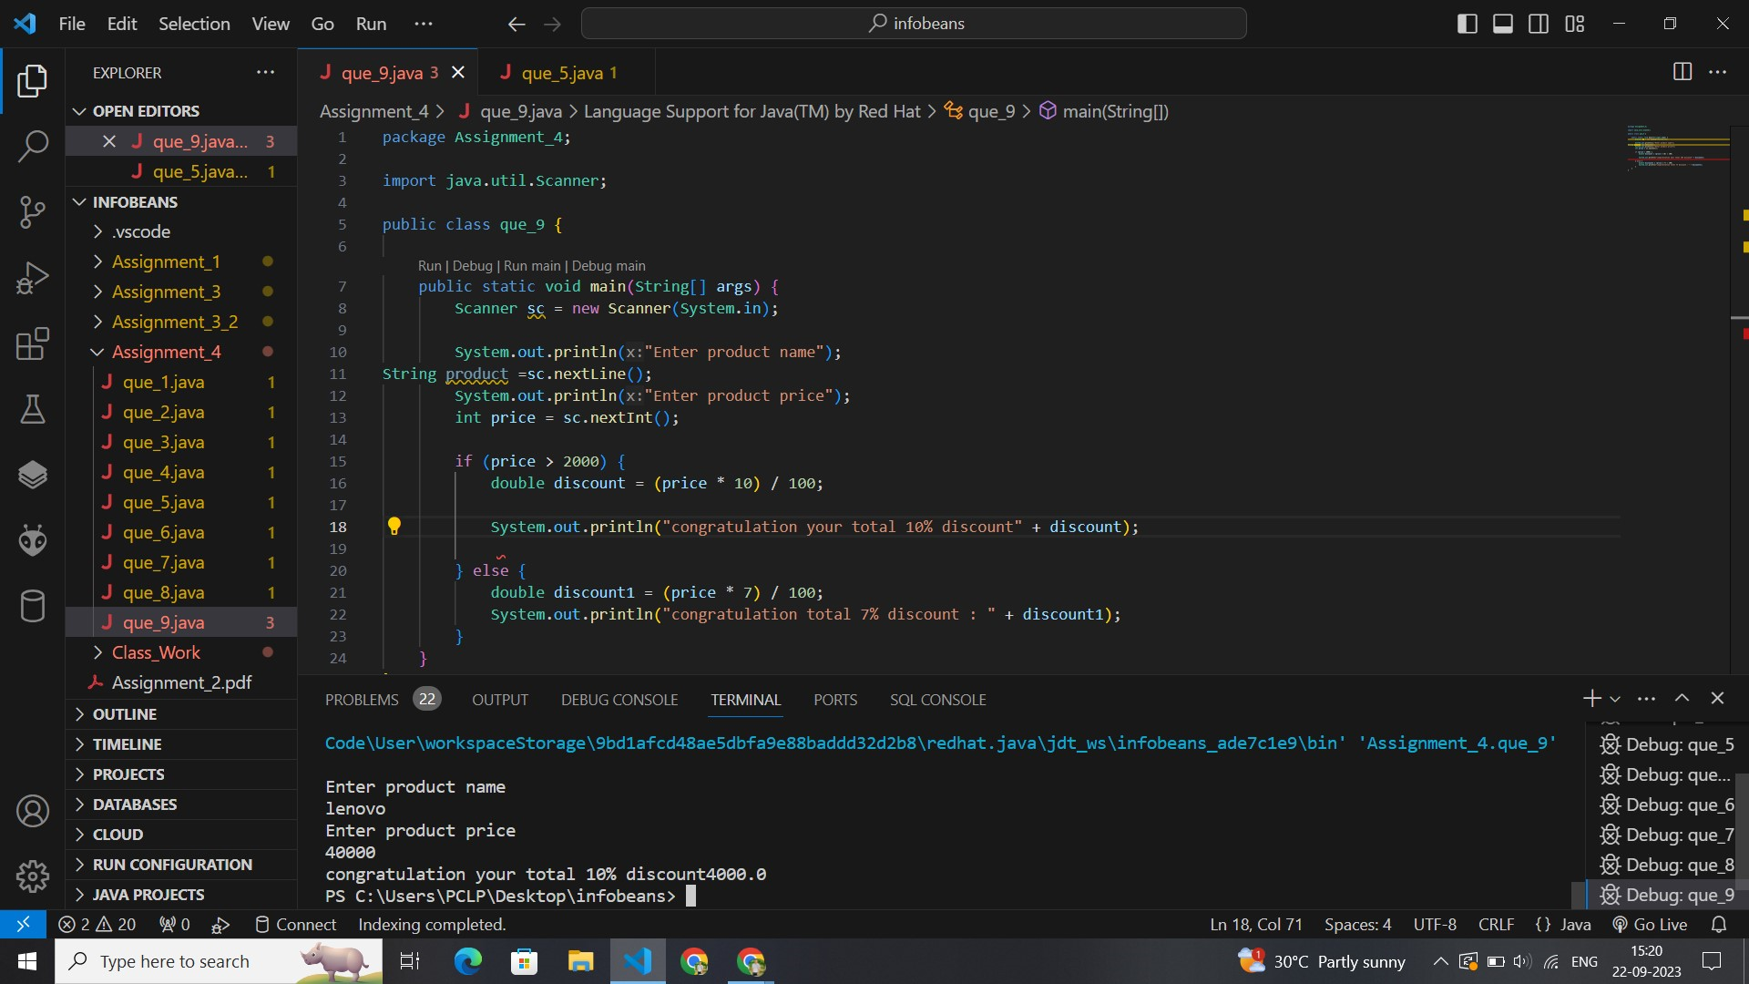

// package Assignment_4;

import java.util.Scanner;

public class que_9 {

    public static void main(String[] args) {

        Scanner sc = new Scanner(System.in);

        System.out.println("Enter product name");

        String product = sc.nextLine();

        System.out.println("Enter product price");

        int price = sc.nextInt();

        if (price > 2000) {

            double discount = (price * 10) / 100;

            System.out.println("congratulation your total 10% discount is " + discount);

        } else {

            double discount1 = (price * 7) / 100;

            System.out.println("congratulation total 7% discount is : " + discount1);

        }

    }

}

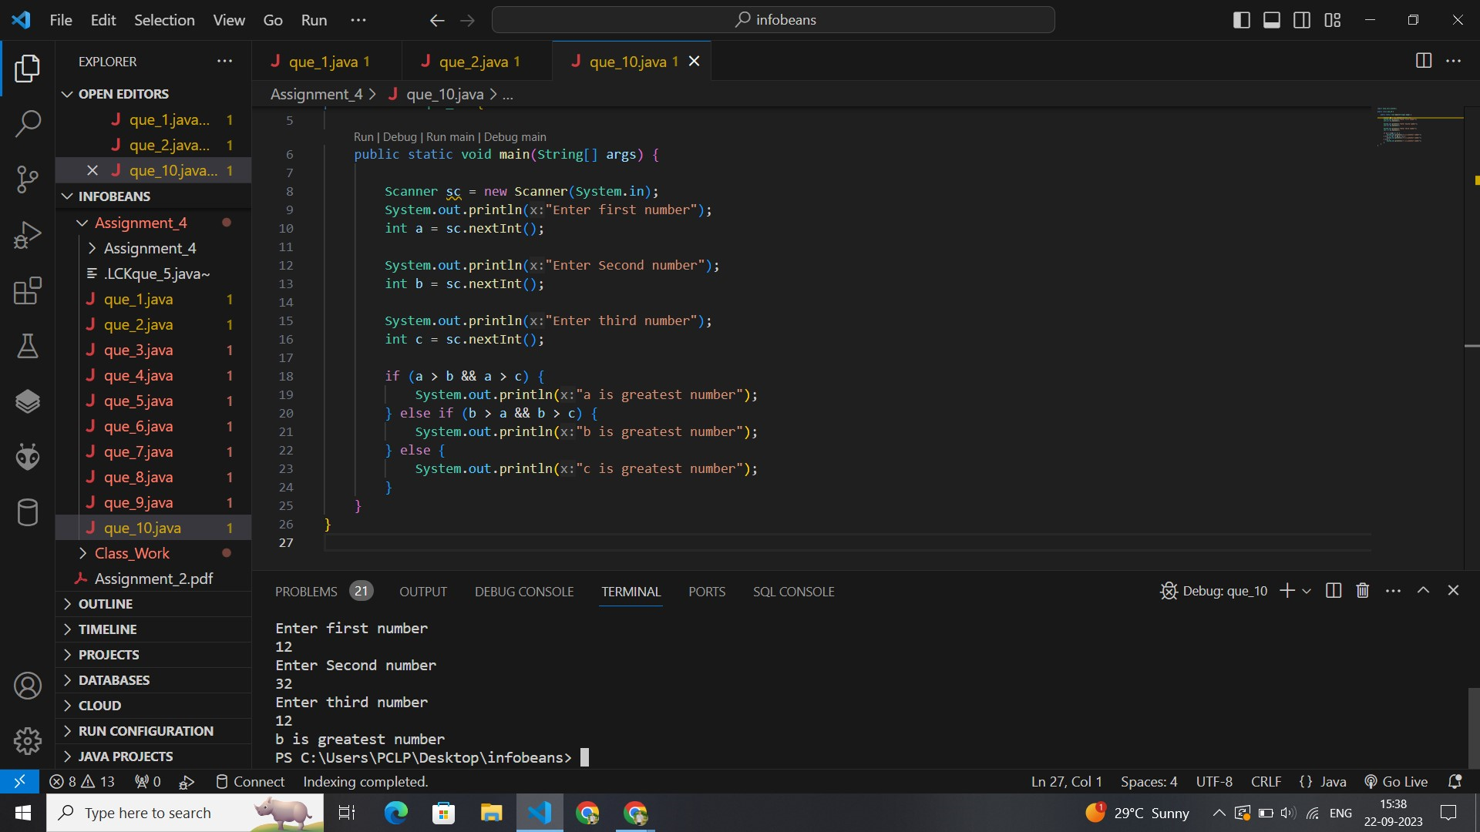

import java.util.Scanner;

public class que_10 {

    public static void main(String[] args) {

        Scanner sc = new Scanner(System.in);

        System.out.println("Enter first number");

        int a = sc.nextInt();

        System.out.println("Enter Second number");

        int b = sc.nextInt();

        System.out.println("Enter third number");

        int c = sc.nextInt();

        if (a > b && a > c) {

            System.out.println("a is greatest number");

        } else if (b > a && b > c) {

            System.out.println("b is greatest number");

        } else {

            System.out.println("c is greatest number");

        }

    }

}

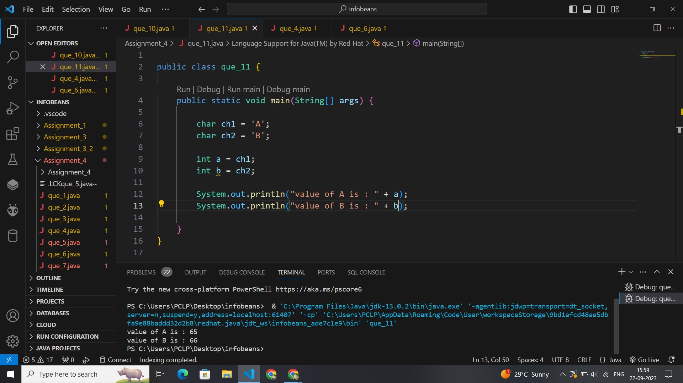

public class que_11 {

    public static void main(String[] args) {

        char ch1 = 'A';

        char ch2 = 'B';

        int a = ch1;

        int b = ch2;

        System.out.println("value of A is : " + a);

        System.out.println("value of B is : " + b);

    }

}

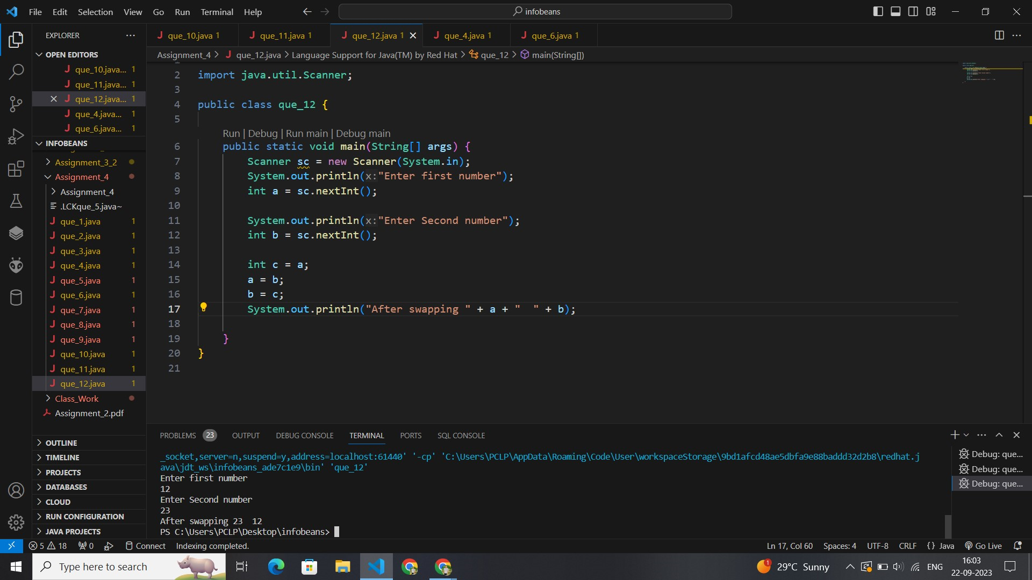

import java.util.Scanner;

public class que_12 {

    public static void main(String[] args) {

        Scanner sc = new Scanner(System.in);

        System.out.println("Enter first number");

        int a = sc.nextInt();

        System.out.println("Enter Second number");

        int b = sc.nextInt();

        System.out.println("before swapping " + a + " " + b);

        int c = a;

        a = b;

        b = c;

        System.out.println("After swapping " + a + "  " + b);

    }

}

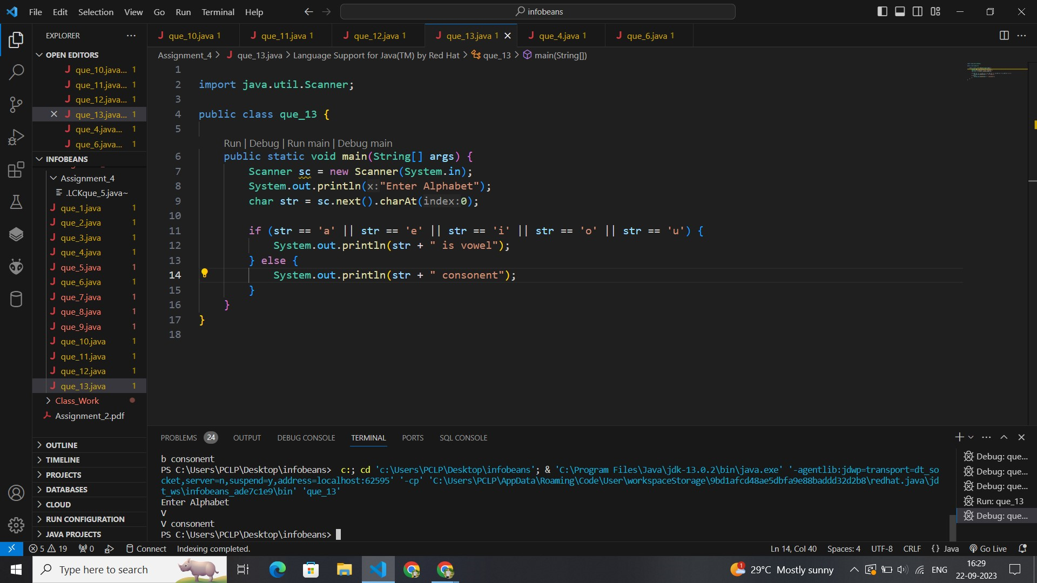

import java.util.Scanner;

public class que_13 {

    public static void main(String[] args) {

        Scanner sc = new Scanner(System.in);

        System.out.println("Enter Alphabet");

        char str = sc.next().charAt(0);

        if (str == 'a' || str == 'e' || str == 'i' || str == 'o' || str == 'u' || str == 'A' || str == 'E' || str == 'I' || str == 'O' || str == 'U') {

            System.out.println(str + " is vowel");

        } else {

            System.out.println(str + " consonent");

        }

    }

}

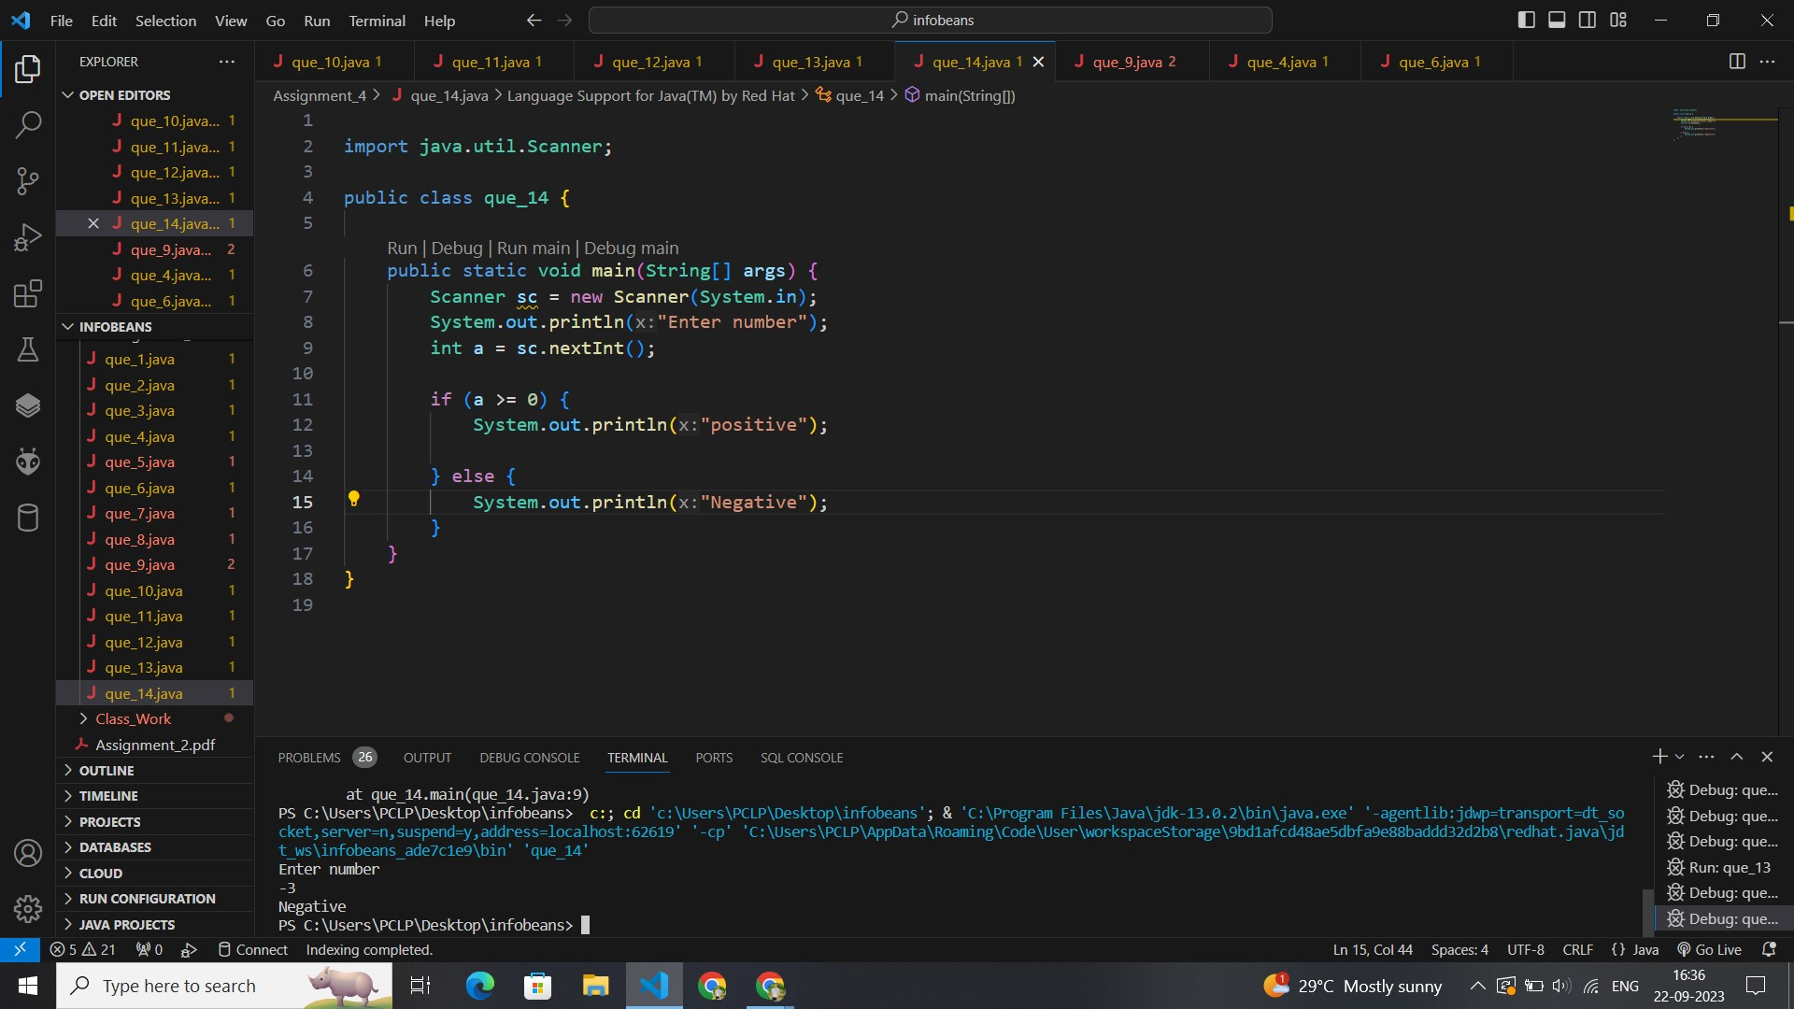

import java.util.Scanner;

public class que_14 {

    public static void main(String[] args) {

        Scanner sc = new Scanner(System.in);

        System.out.println("Enter number");

        int a = sc.nextInt();

        if (a >= 0) {

            System.out.println("positive");

        } else {

            System.out.println("Negative");

        }

    }

}

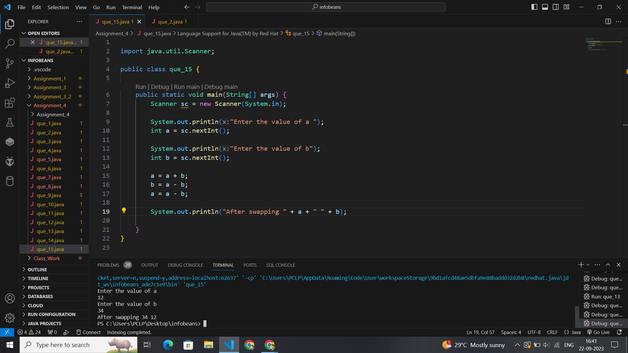

import java.util.Scanner;

public class que_15 {

    public static void main(String[] args) {

        Scanner sc = new Scanner(System.in);

        System.out.println("Enter the value of a ");

        int a = sc.nextInt();

        System.out.println("Enter the value of b");

        int b = sc.nextInt();

        a = a + b;

        b = a - b;

        a = a - b;

        System.out.println("After swapping " + a + " " + b);

    }

}

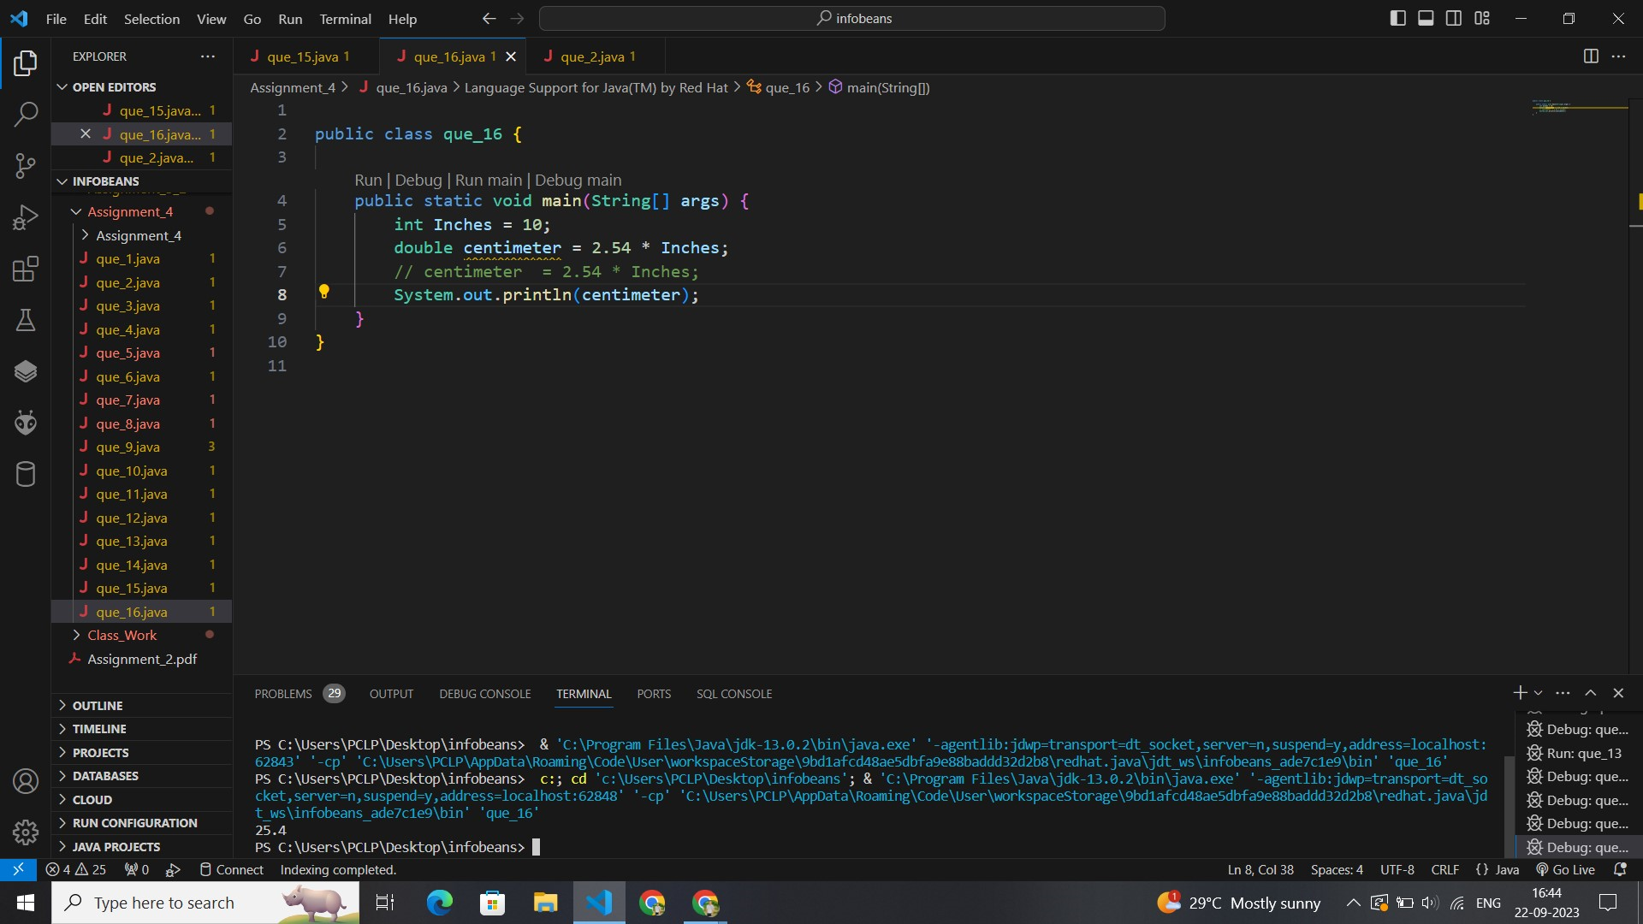

public class que_16 {

    public static void main(String[] args) {

        int Inches = 10;

        double centimeter = 2.54 * Inches;

        // centimeter  = 2.54 * Inches;

        System.out.println(centimeter);

    }

}

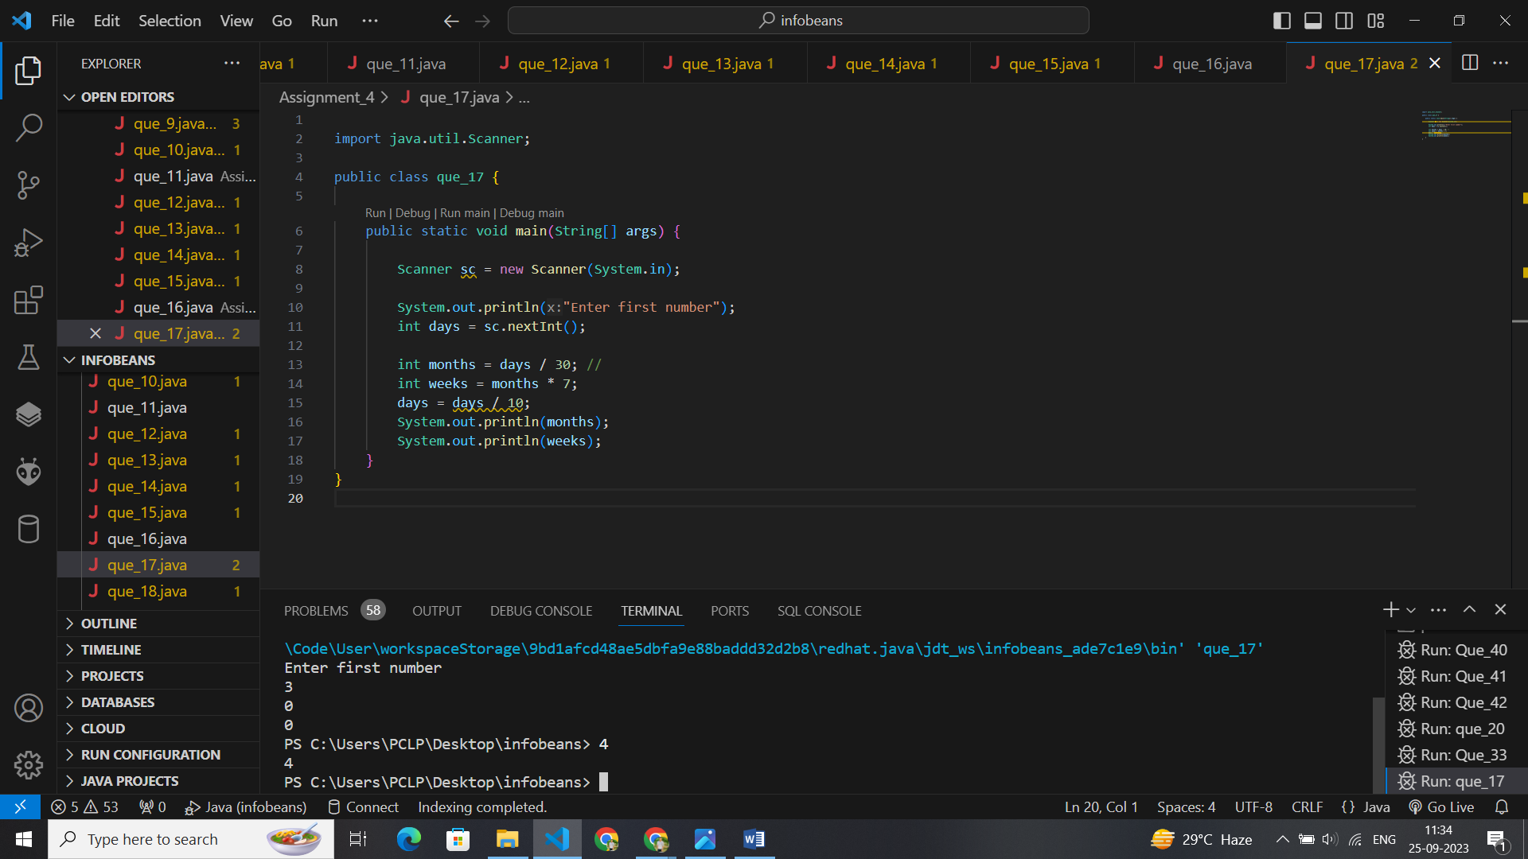

import java.util.Scanner;

public class que_17 {

    public static void main(String[] args) {

        Scanner sc = new Scanner(System.in);

        System.out.println("Enter first number");

        int days = sc.nextInt();

        int months = days / 30; //

        int weeks = months * 7;

        days = days / 10;

        System.out.println(months);

        System.out.println(weeks);

    }

}

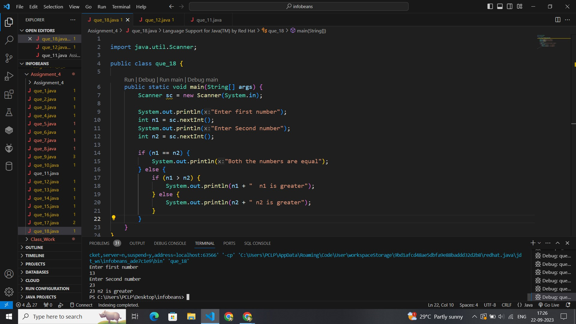

import java.util.Scanner;

public class que_18 {

    public static void main(String[] args) {

        Scanner sc = new Scanner(System.in);

        System.out.println("Enter first number");

        int n1 = sc.nextInt();

        System.out.println("Enter Second number");

        int n2 = sc.nextInt();

        if (n1 == n2) {

            System.out.println("Both the numbers are equal");

        } else {

            if (n1 > n2) {

                System.out.println(n1 + "  n1 is greater");

            } else {

                System.out.println(n2 + " n2 is greater");

            }

        }

    }

}

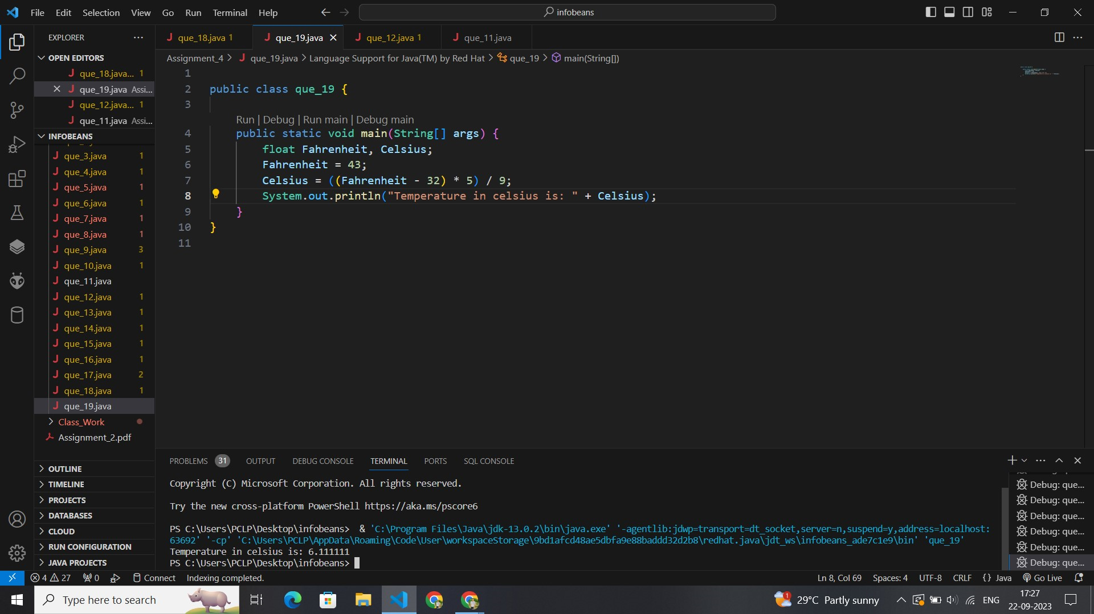

public class que_19 {

    public static void main(String[] args) {

        float Fahrenheit, Celsius;

        Fahrenheit = 43;

        Celsius = ((Fahrenheit - 32) * 5) / 9;

        System.out.println("Temperature in celsius is: " + Celsius);

    }

}

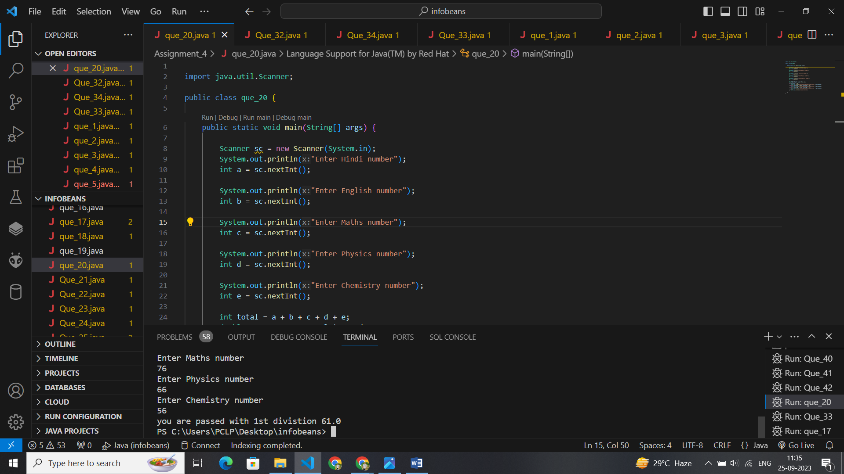

import java.util.Scanner;

public class que_20 {

    public static void main(String[] args) {

        Scanner sc = new Scanner(System.in);

        System.out.println("Enter Hindi number");

        int a = sc.nextInt();

        System.out.println("Enter English number");

        int b = sc.nextInt();

        System.out.println("Enter Maths number");

        int c = sc.nextInt();

        System.out.println("Enter Physics number");

        int d = sc.nextInt();

        System.out.println("Enter Chemistry number");

        int e = sc.nextInt();

        int total = a + b + c + d + e;

        double percentage = total * 100 / 500;

        if (percentage >= 60) {

            System.out.println("you are passed with 1st divistion " + percentage);

        } else if (percentage >= 50 && percentage <= 59) {

            System.out.println("you are passed with 2nd divistion " + percentage);

        } else if (percentage >= 33 && percentage <= 49) {

            System.out.println("you are passed with 3rd divistion " + percentage);

        } else {

            System.out.println("you are failed");}

    }

}

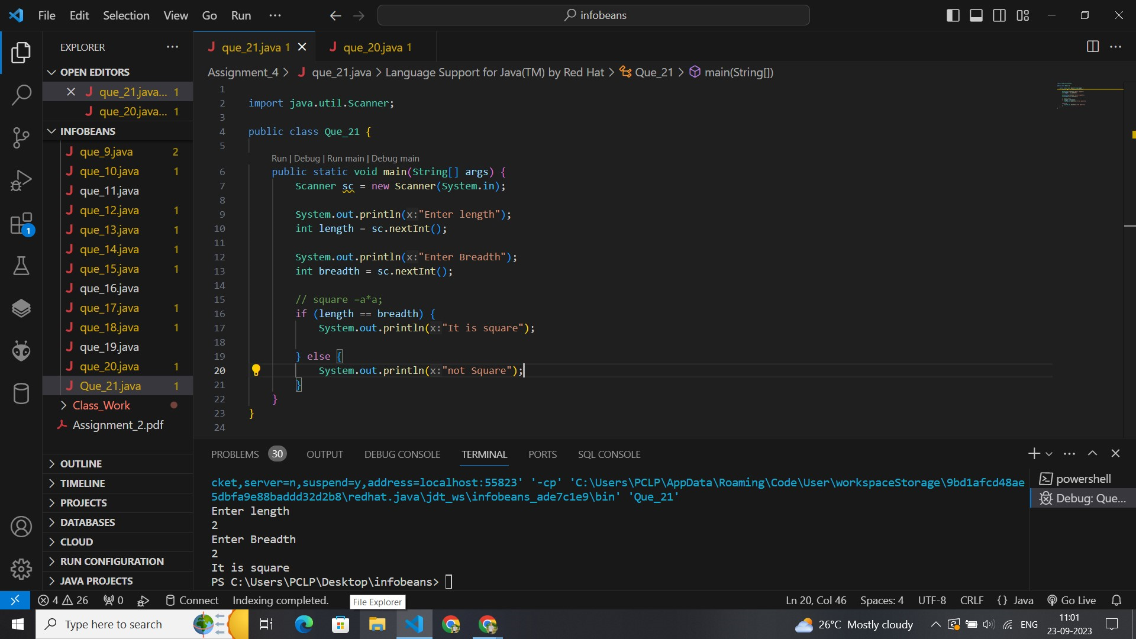

import java.util.Scanner;

public class Que_21 {

    public static void main(String[] args) {

        Scanner sc = new Scanner(System.in);

        System.out.println("Enter length");

        int length = sc.nextInt();

        System.out.println("Enter Breadth");

        int breadth = sc.nextInt();

        // square =a*a;

        if (length == breadth) {

            System.out.println("It is square");

        } else {

            System.out.println("not Square");

        }

    }

}

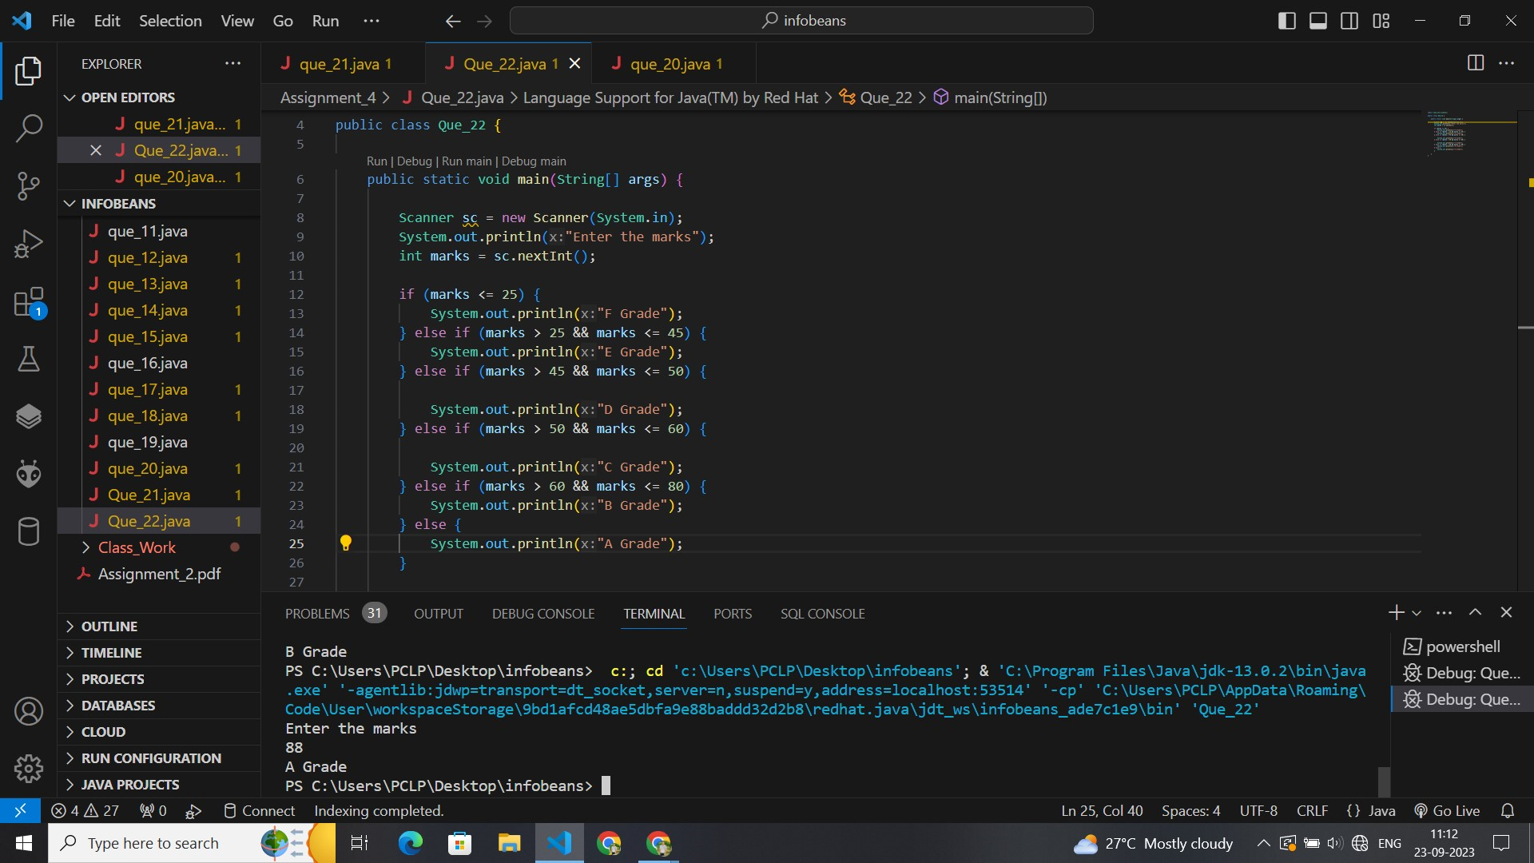

import java.util.Scanner;

public class Que_22 {

    public static void main(String[] args) {

        Scanner sc = new Scanner(System.in);

        System.out.println("Enter the marks");

        int marks = sc.nextInt();

        if (marks <= 25) {

            System.out.println("F Grade");

        } else if (marks > 25 && marks <= 45) {

            System.out.println("E Grade");

        } else if (marks > 45 && marks <= 50) {

            System.out.println("D Grade");

        } else if (marks > 50 && marks <= 60) {

            System.out.println("C Grade");

        } else if (marks > 60 && marks <= 80) {

            System.out.println("B Grade");

        } else {

            System.out.println("A Grade");

        }

    }

}

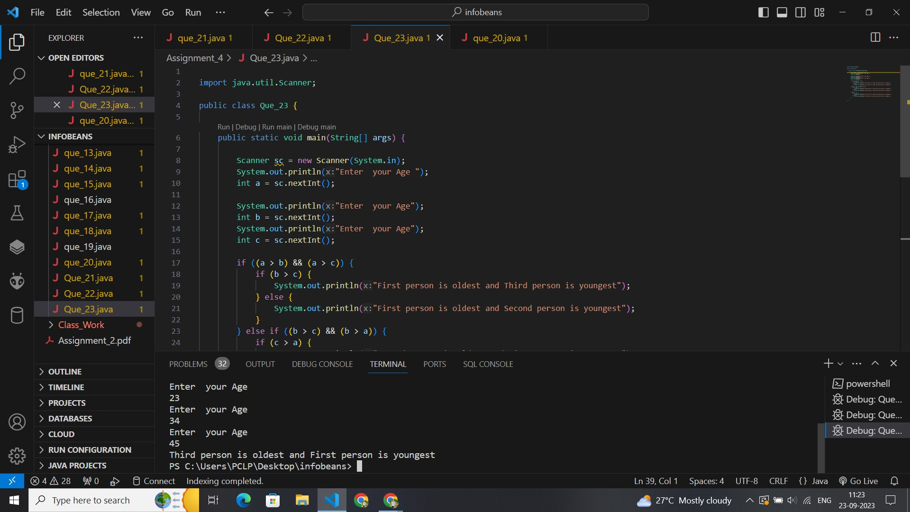

import java.util.Scanner;

public class Que_23 {

    public static void main(String[] args) {

        Scanner sc = new Scanner(System.in);

        System.out.println("Enter  your Age ");

        int a = sc.nextInt();

        System.out.println("Enter  your Age");

        int b = sc.nextInt();

        System.out.println("Enter  your Age");

        int c = sc.nextInt();

        if ((a > b) && (a > c)) {

            if (b > c) {

                System.out.println("First person is oldest and Third person is youngest");

            } else {

                System.out.println("First person is oldest and Second person is youngest");

            }

        } else if ((b > c) && (b > a)) {

            if (c > a) {

                System.out.println("Second person is oldest and First person is youngest");

            } else {

                System.out.println("Second person is oldest and Third person is youngest");

            }

        } else {

            if (a > b) {

                System.out.println("Third person is oldest and Second person is youngest");

            } else {

                System.out.println("Third person is oldest and First person is youngest");

            }

        }

    }

}

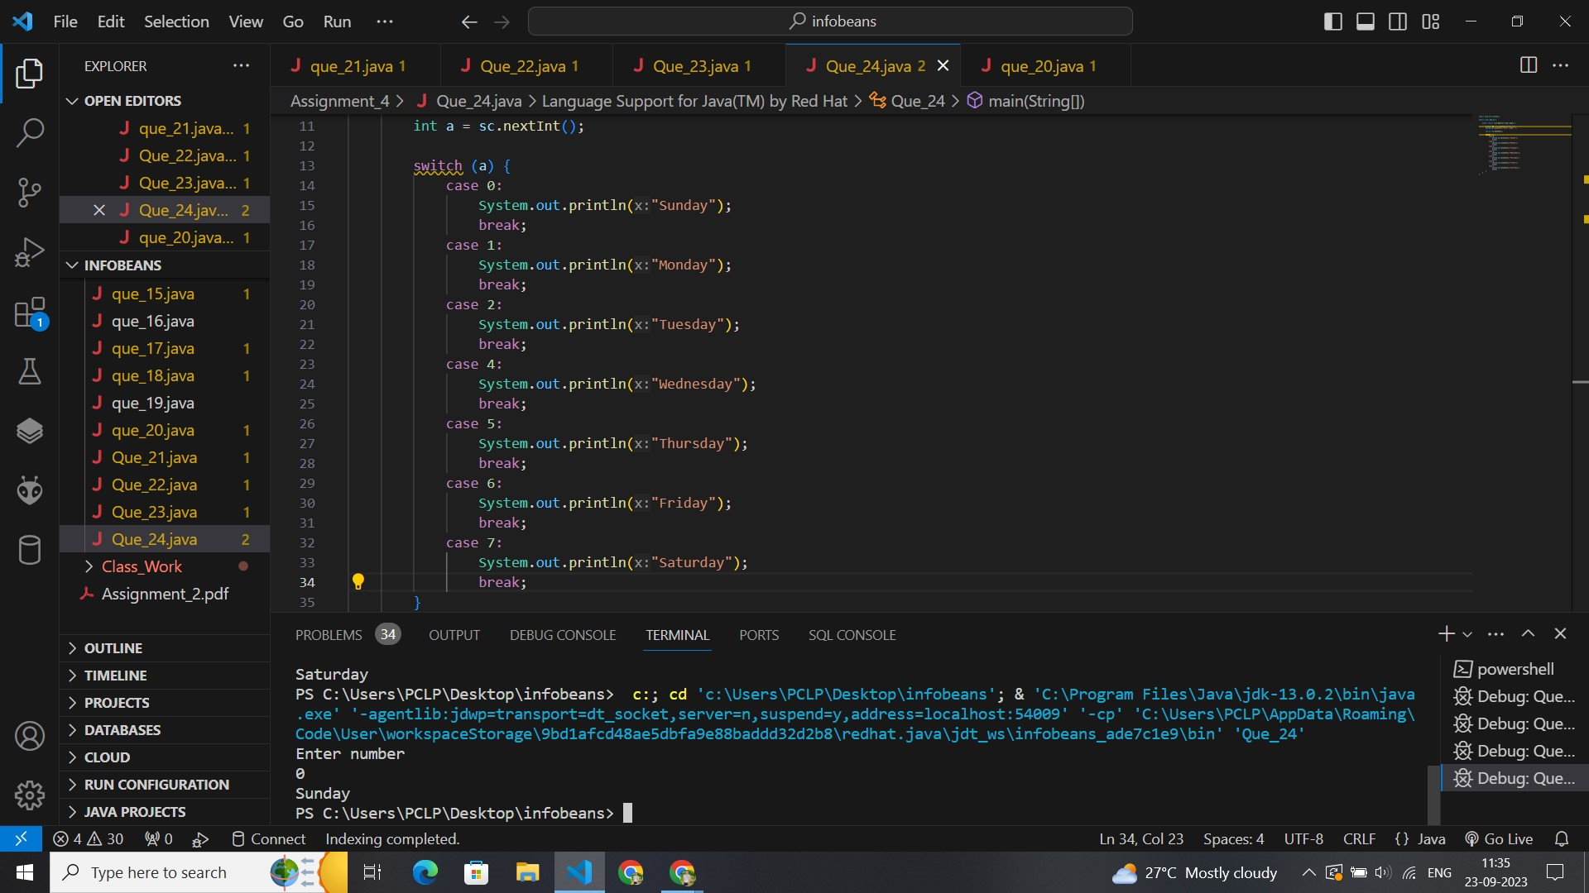

import java.util.Scanner;

public class Que_24 {

    public static void main(String[] args) {

        Scanner sc = new Scanner(System.in);

        System.out.println("Enter number ");

        int a = sc.nextInt();

        switch (a) {

            case 0:

                System.out.println("Sunday");

                break;

            case 1:

                System.out.println("Monday");

                break;

            case 2:

                System.out.println("Tuesday");

                break;

            case 3:

                System.out.println("Wednesday");

                break;

            case 4:

                System.out.println("Thursday");

                break;

            case 5:

                System.out.println("Friday");

                break;

            case 7:

                System.out.println("Saturday");

                break;

            default:

                System.out.println("choose right number");

        }

    }

}

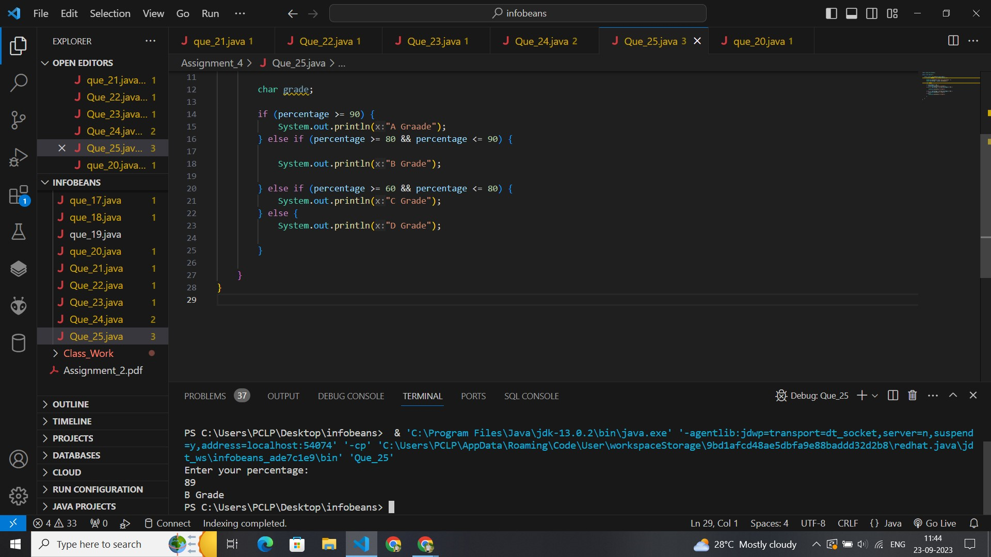

import java.util.Scanner;

public class Que_25 {

    public static void main(String[] args) {

        Scanner scanner = new Scanner(System.in);

        System.out.println("Enter your percentage: ");

        double percentage = scanner.nextDouble();

        char grade;

        if (percentage >= 90) {

            System.out.println("A Graade");

        } else if (percentage >= 80 && percentage <= 90) {

            System.out.println("B Grade");

        } else if (percentage >= 60 && percentage <= 80) {

            System.out.println("C Grade");

        } else {

            System.out.println("D Grade");

        }

    }

}

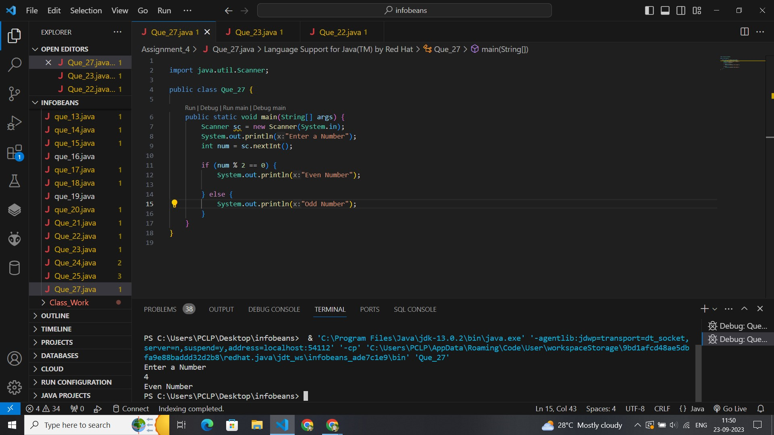

import java.util.Scanner;

public class Que_27 {

    public static void main(String[] args) {

        Scanner sc = new Scanner(System.in);

        System.out.println("Enter a Number");

        int num = sc.nextInt();

        if (num % 2 == 0) {

            System.out.println("Even Number");

        } else {

            System.out.println("Odd Number");

        }

    }

}

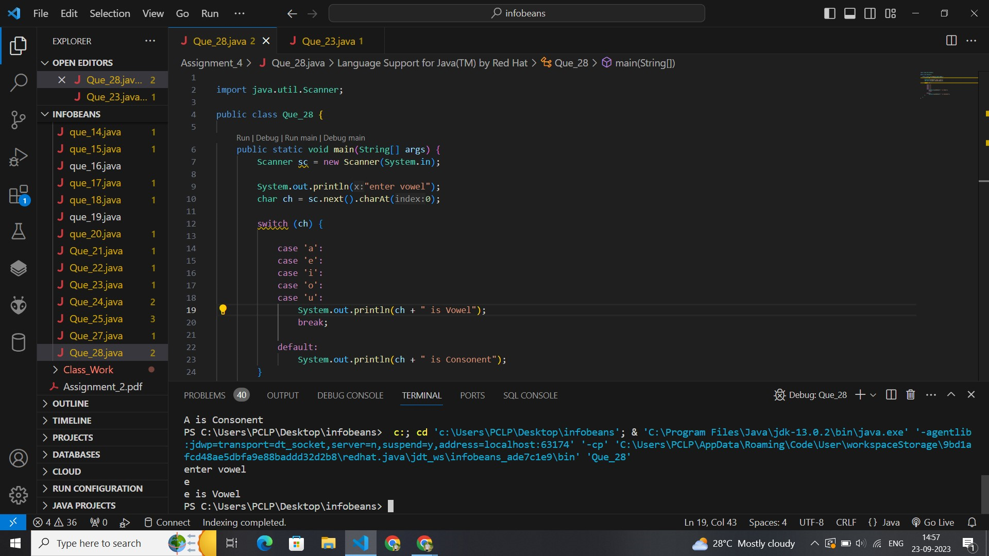

import java.util.Scanner;

public class Que_28 {

    public static void main(String[] args) {

        Scanner sc = new Scanner(System.in);

        System.out.println("enter Alphabet ");

        char str = sc.next().charAt(0);

        //  ch = ch.toLowerCase();

        if (str == 'a' || str == 'e' || str == 'i' || str == 'o' || str == 'u' || str == 'A' || str == 'E' || str == 'I' || str == 'O' || str == 'U') {

            System.out.println(str + " is vowel");

        } else {

            System.out.println(str + " consonent");

        }

    }

}

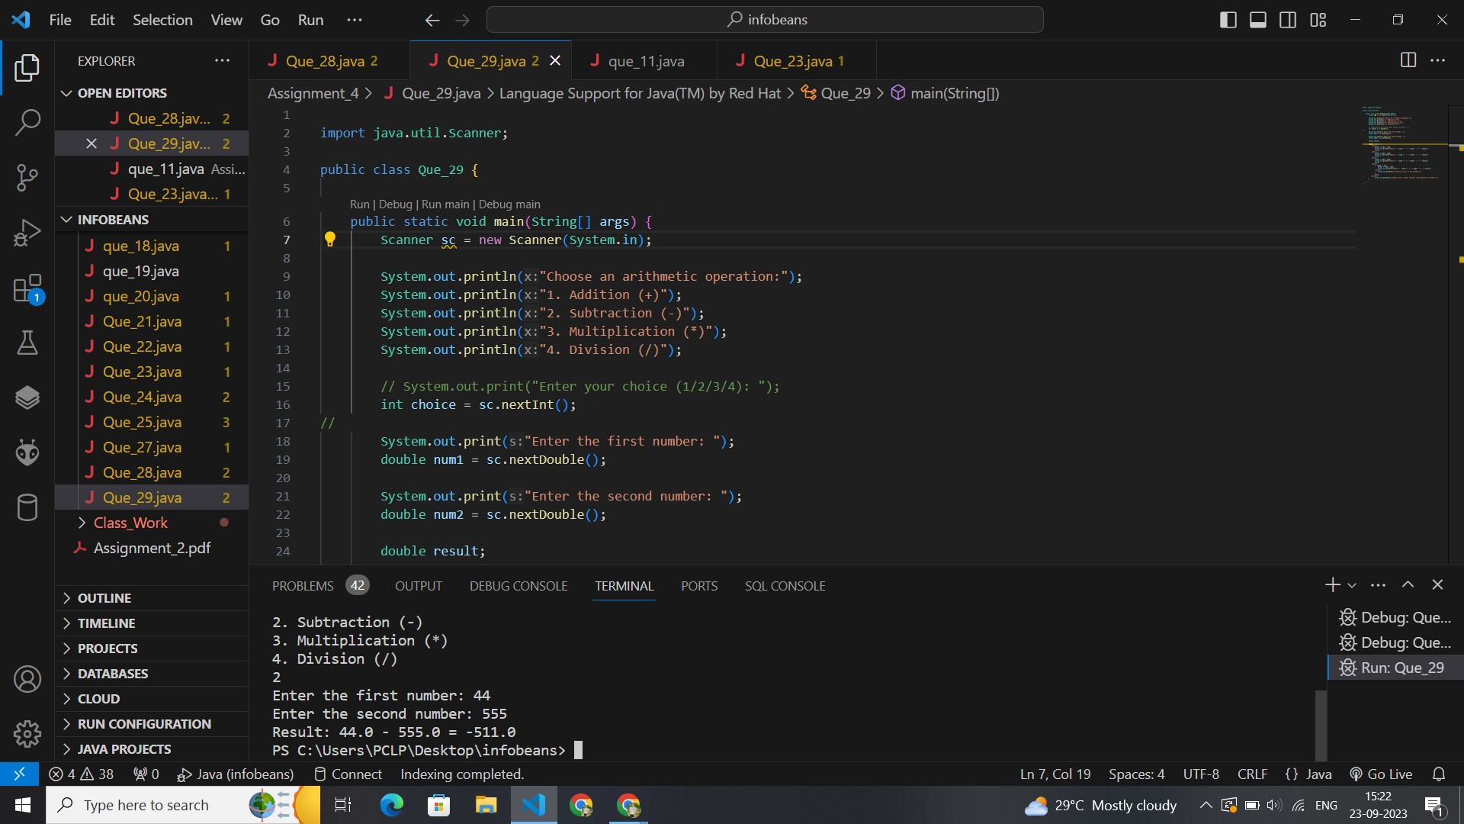

import java.util.Scanner;

public class Que_29 {

    public static void main(String[] args) {

        Scanner sc = new Scanner(System.in);

        System.out.println("Choose an arithmetic operation:");

        System.out.println("1. Addition (+)");

        System.out.println("2. Subtraction (-)");

        System.out.println("3. Multiplication (*)");

        System.out.println("4. Division (/)");

        // System.out.print("Enter your choice (1/2/3/4): ");

        int choice = sc.nextInt();

//

        System.out.print("Enter the first number: ");

        double num1 = sc.nextDouble();

        System.out.print("Enter the second number: ");

        double num2 = sc.nextDouble();

        double result;

        switch (choice) {

            case 1:

                result = num1 + num2;

                System.out.println("Result: " + num1 + " + " + num2 + " = " + result);

                break;

            case 2:

                result = num1 - num2;

                System.out.println("Result: " + num1 + " - " + num2 + " = " + result);

                break;

            case 3:

                result = num1 * num2;

                System.out.println("Result: " + num1 + " * " + num2 + " = " + result);

                break;

            case 4:

                if (num2 != 0) {

                    result = num1 / num2;

                    System.out.println("Result: " + num1 + " / " + num2 + " = " + result);

                } else {

                    System.out.println("Division by zero is not allowed.");

                }

                break;

            default:

                System.out.println("Invalid choice. Please choose a valid operation (1/2/3/4).");

        }

    }

}

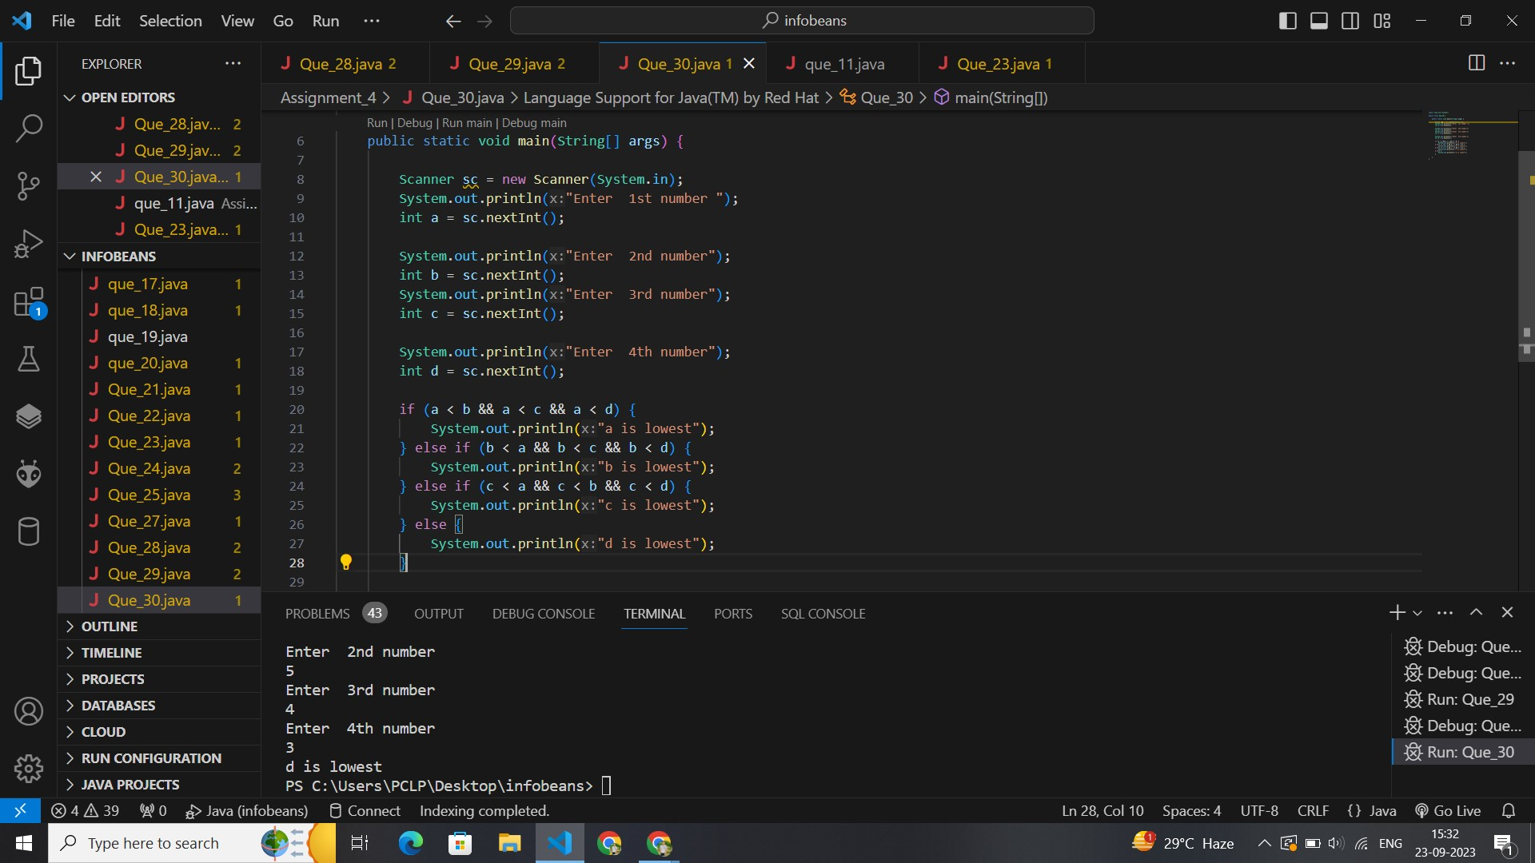

import java.util.Scanner;

public class Que_30 {

    public static void main(String[] args) {

        Scanner sc = new Scanner(System.in);

        System.out.println("Enter  1st number ");

        int a = sc.nextInt();

        System.out.println("Enter  2nd number");

        int b = sc.nextInt();

        System.out.println("Enter  3rd number");

        int c = sc.nextInt();

        System.out.println("Enter  4th number");

        int d = sc.nextInt();

        if (a < b && a < c && a < d) {

            System.out.println("a is lowest");

        } else if (b < a && b < c && b < d) {

            System.out.println("b is lowest");

        } else if (c < a && c < b && c < d) {

            System.out.println("c is lowest");

        } else {

            System.out.println("d is lowest");

        }

    }

}

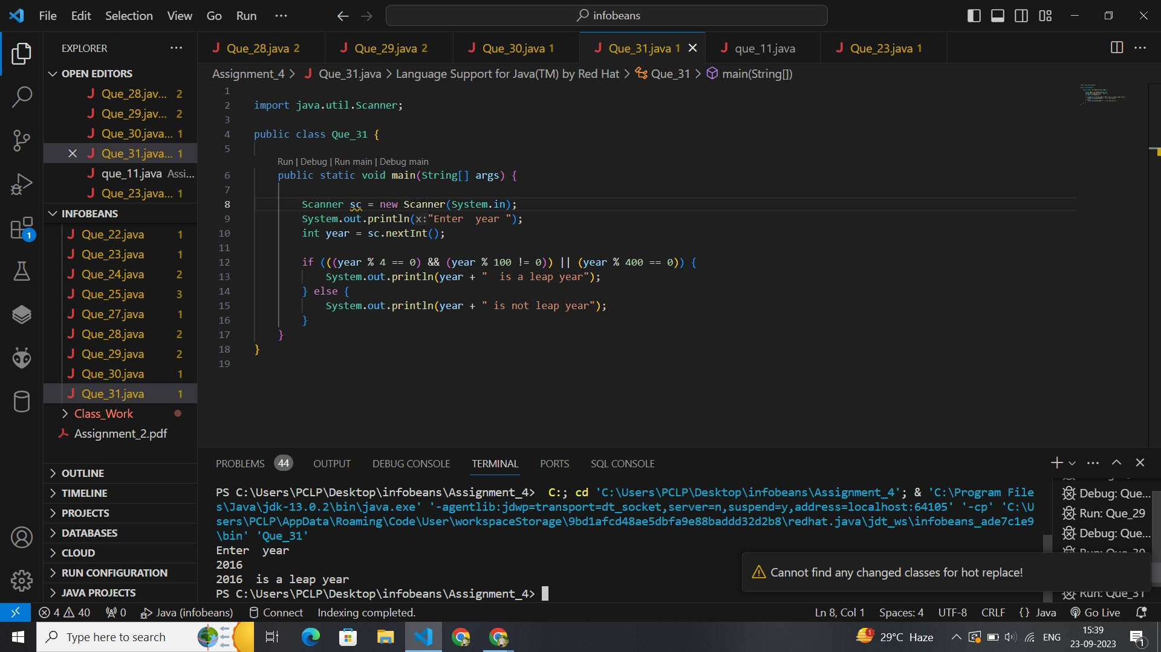

import java.util.Scanner;

public class Que_31 {

    public static void main(String[] args) {

        Scanner sc = new Scanner(System.in);

        System.out.println("Enter  year ");

        int year = sc.nextInt();

        if (((year % 4 == 0) && (year % 100 != 0)) || (year % 400 == 0)) {

            System.out.println(year + "  is a leap year");

        } else {

            System.out.println(year + " is not leap year");

        }

    }

}

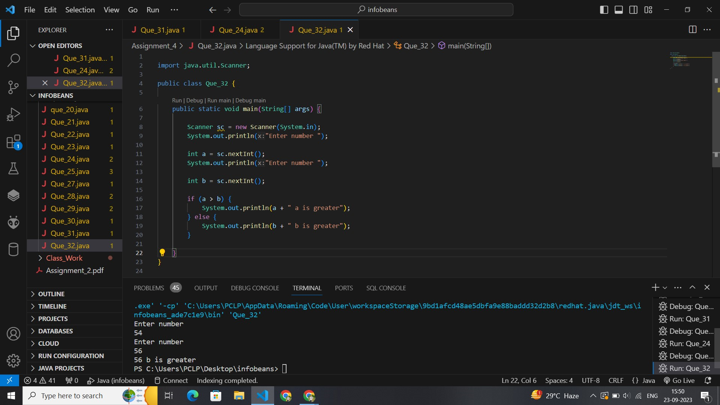

import java.util.Scanner;

public class Que_32 {

    public static void main(String[] args) {

        Scanner sc = new Scanner(System.in);

        System.out.println("Enter number ");

        int a = sc.nextInt();

        System.out.println("Enter number ");

        int b = sc.nextInt();

        if (a > b) {

            System.out.println(a + " a is greater");

        } else {

            System.out.println(b + " b is greater");

        }

    }

}

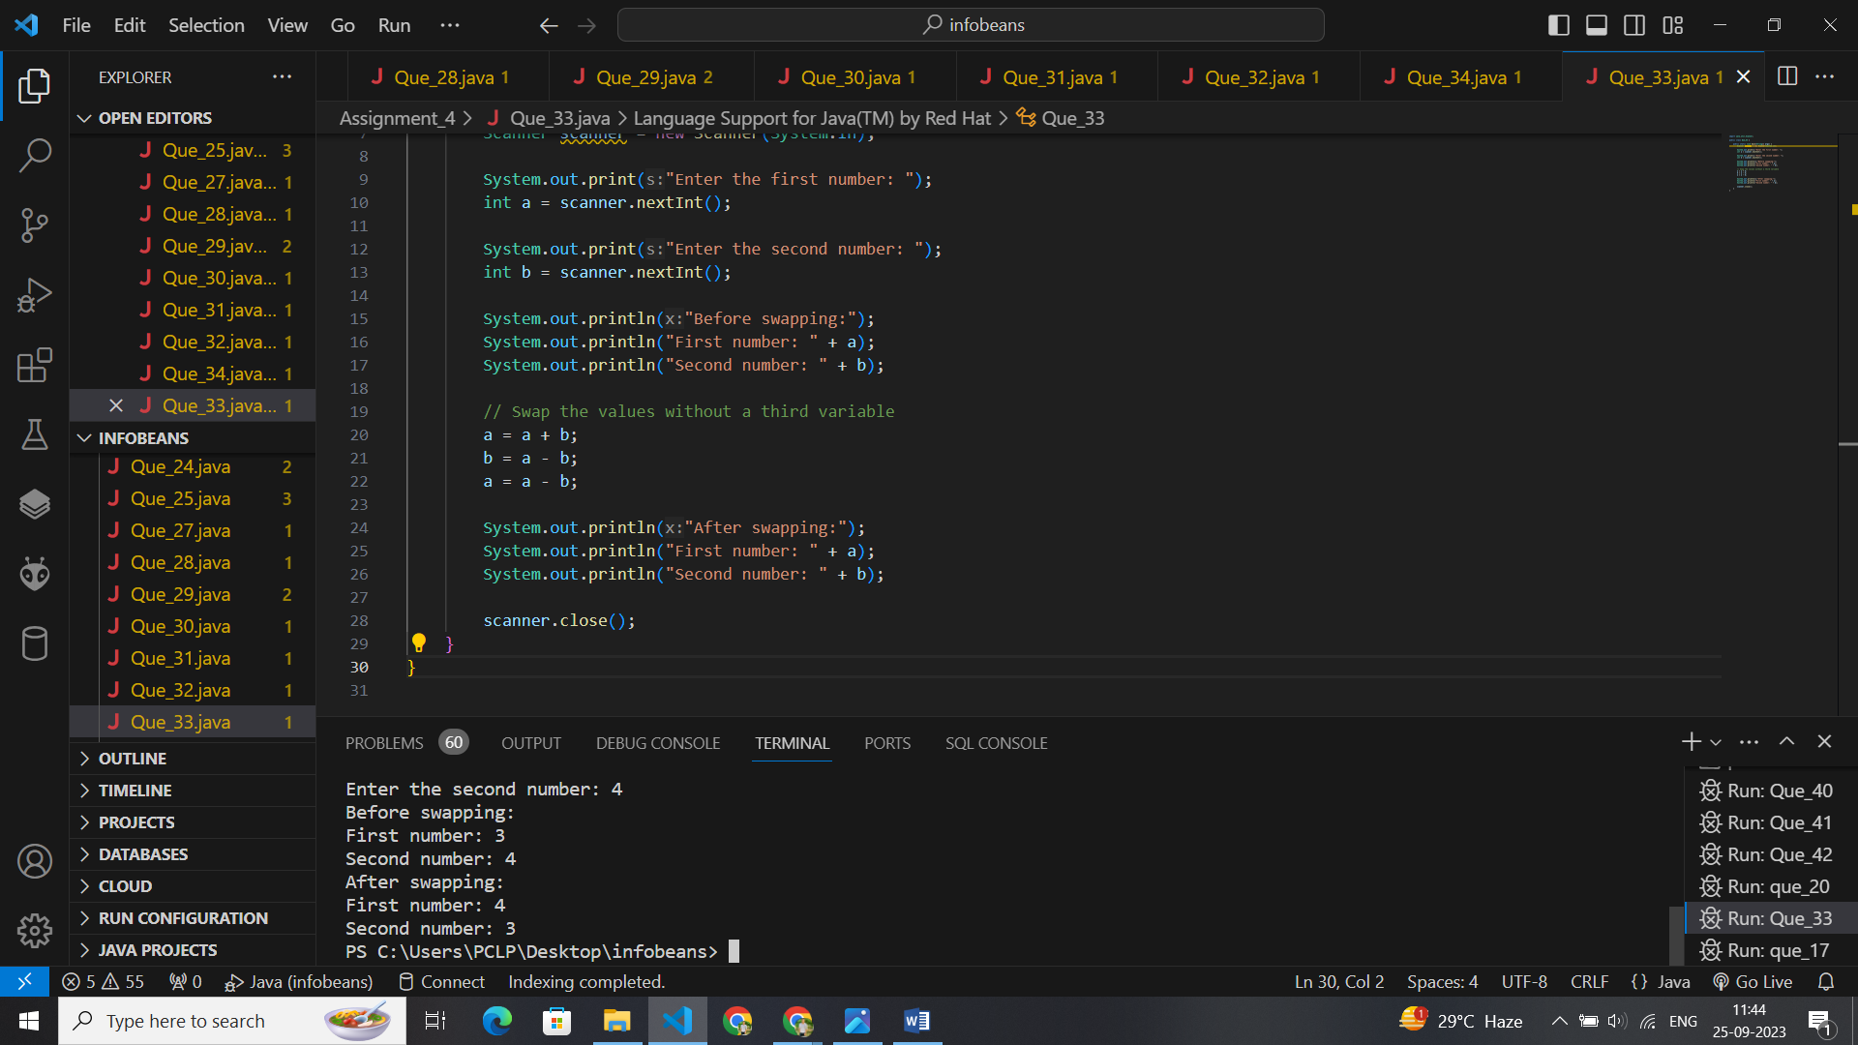

import java.util.Scanner;

public class Que_33 {

    public static void main(String[] args) {

        Scanner scanner = new Scanner(System.in);

        System.out.print("Enter the first number: ");

        int a = scanner.nextInt();

        System.out.print("Enter the second number: ");

        int b = scanner.nextInt();

        System.out.println("Before swapping:");

        System.out.println("First number: " + a);

        System.out.println("Second number: " + b);

        // Swap the values without a third variable

        a = a + b;

        b = a - b;

        a = a - b;

        System.out.println("After swapping:");

        System.out.println("First number: " + a);

        System.out.println("Second number: " + b);

        scanner.close();

    }

}

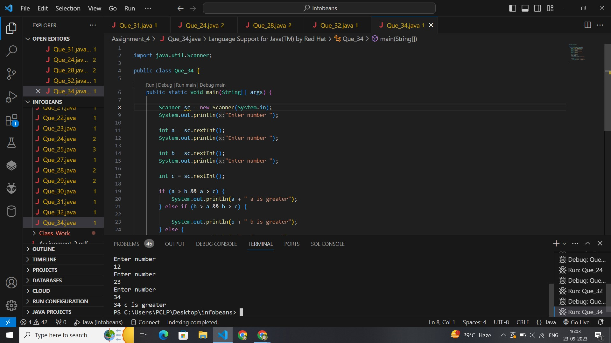

import java.util.Scanner;

public class Que_34 {

    public static void main(String[] args) {

        Scanner sc = new Scanner(System.in);

        System.out.println("Enter number ");

        int a = sc.nextInt();

        System.out.println("Enter number ");

        int b = sc.nextInt();

        System.out.println("Enter number ");

        int c = sc.nextInt();

        if (a > b && a > c) {

            System.out.println(a + " a is greater");

        } else if (b > a && b > c) {

            System.out.println(b + " b is greater");

        } else {

            System.out.println(c+" c is greater");

        }

    }

}

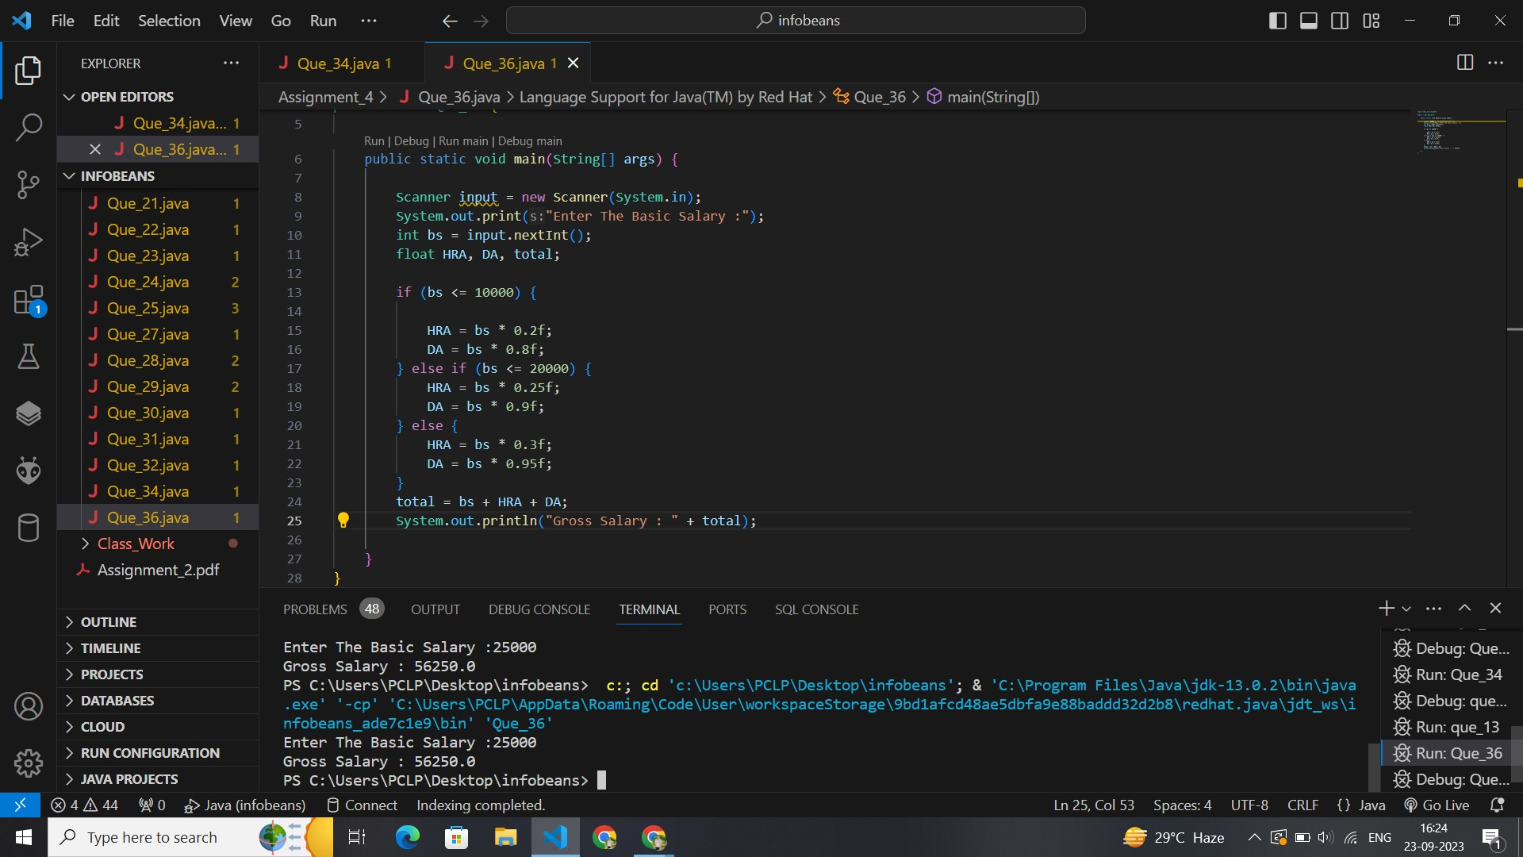

import java.util.Scanner;

public class Que_36 {

    public static void main(String[] args) {

        Scanner input = new Scanner(System.in);

        System.out.print("Enter The Basic Salary :");

        int bs = input.nextInt();

        float HRA, DA, total;

        if (bs <= 10000) {

            HRA = bs * 0.2f;

            DA = bs * 0.8f;

            total = bs + HRA + DA;

            System.out.println("Gross Salary : " + total);

        } else if (bs <= 20000) {

            HRA = bs * 0.25f;

            DA = bs * 0.9f;

            total = bs + HRA + DA;

            System.out.println("Gross Salary : " + total);

        } else {

            HRA = bs * 0.3f;

            DA = bs * 0.95f;

            total = bs + HRA + DA;

            System.out.println("Gross Salary : " + total);

        }

        // total = bs + HRA + DA;

        // System.out.println("Gross Salary : " + total);

    }

}

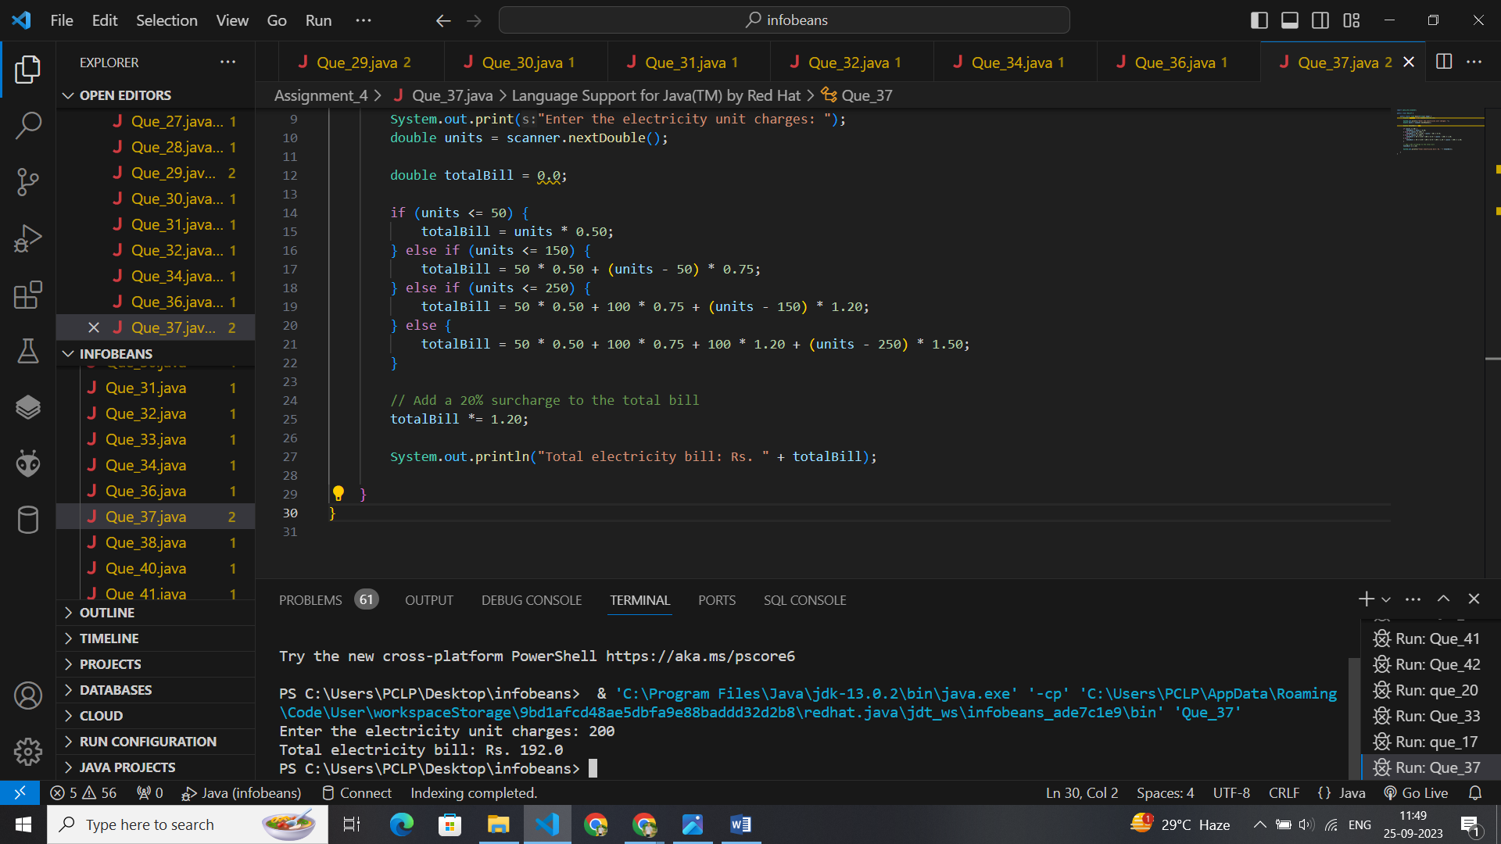

import java.util.Scanner;

public class Que_37 {

    public static void main(String[] args) {

        Scanner scanner = new Scanner(System.in);

        System.out.print("Enter the electricity unit charges: ");

        double units = scanner.nextDouble();

        double totalBill = 0.0;

        if (units <= 50) {

            totalBill = units * 0.50;

        } else if (units <= 150) {

            totalBill = 50 * 0.50 + (units - 50) * 0.75;

        } else if (units <= 250) {

            totalBill = 50 * 0.50 + 100 * 0.75 + (units - 150) * 1.20;

        } else {

            totalBill = 50 * 0.50 + 100 * 0.75 + 100 * 1.20 + (units - 250) * 1.50;

        }

        // Add a 20% surcharge to the total bill

        totalBill *= 1.20;

        System.out.println("Total electricity bill: Rs. " + totalBill);

    }

}

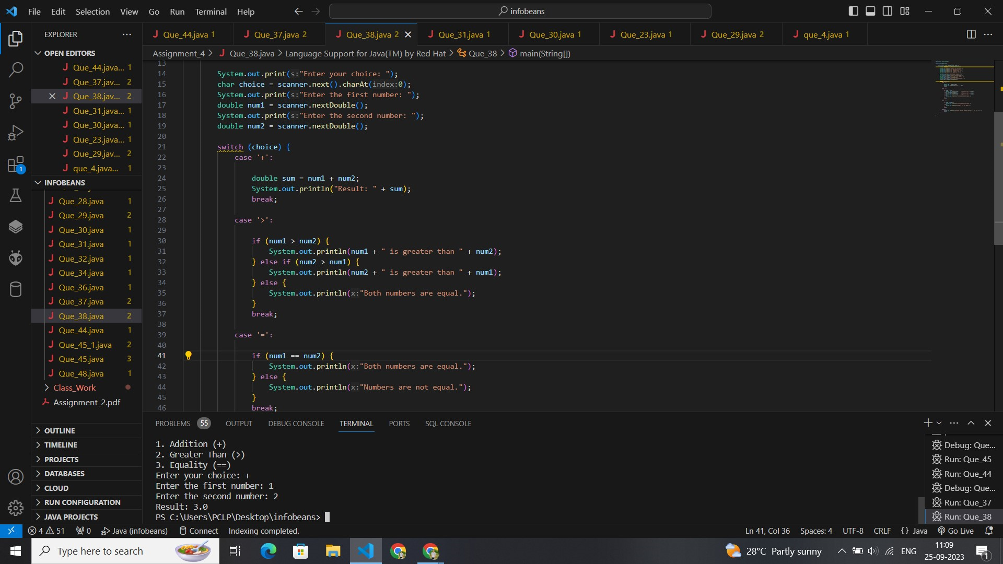

import java.util.Scanner;

public class Que_38 {

    public static void main(String[] args) {

        Scanner scanner = new Scanner(System.in);

        System.out.println("Choose an operation:");

        System.out.println("1. Addition (+)");

        System.out.println("2. Greater Than (>)");

        System.out.println("3. Equality (==)");

        System.out.print("Enter your choice: ");

        char choice = scanner.next().charAt(0);

        System.out.print("Enter the first number: ");

        double num1 = scanner.nextDouble();

        System.out.print("Enter the second number: ");

        double num2 = scanner.nextDouble();

        switch (choice) {

            case '+':

                double sum = num1 + num2;

                System.out.println("Result: " + sum);

                break;

            case '>':

                if (num1 > num2) {

                    System.out.println(num1 + " is greater than " + num2);

                } else if (num2 > num1) {

                    System.out.println(num2 + " is greater than " + num1);

                } else {

                    System.out.println("Both numbers are equal.");

                }

                break;

            case '=':

                if (num1 == num2) {

                    System.out.println("Both numbers are equal.");

                } else {

                    System.out.println("Numbers are not equal.");

                }

                break;

            default:

                System.out.println("Invalid choice. Please choose '+', '>', or '=='.");

                break;

        }

    }

}

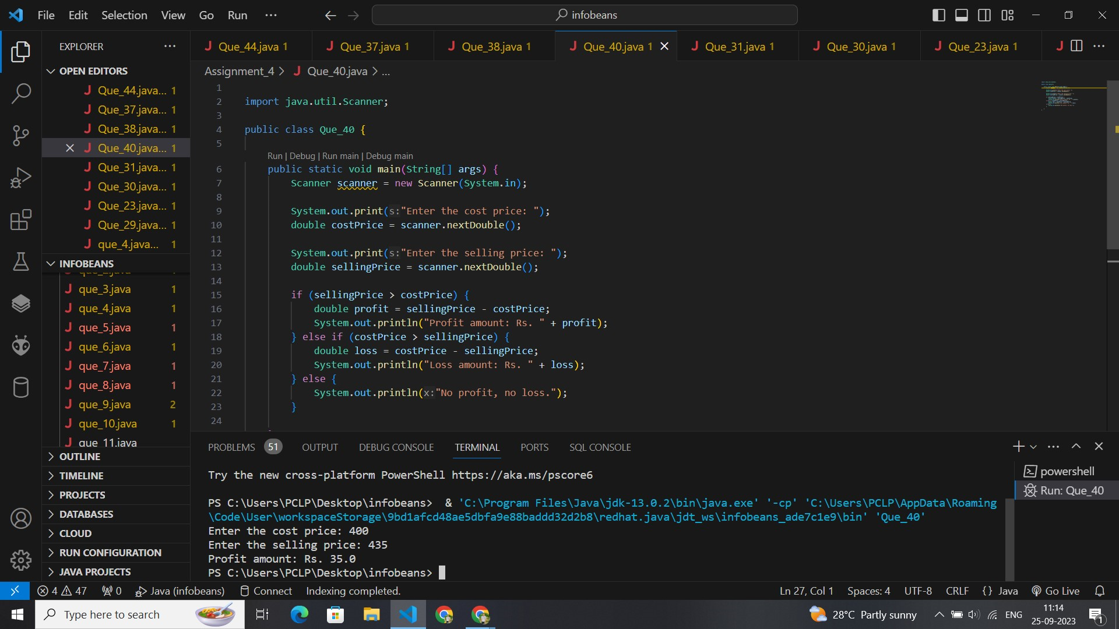

import java.util.Scanner;

public class Que_40 {

    public static void main(String[] args) {

        Scanner scanner = new Scanner(System.in);

        System.out.print("Enter the cost price: ");

        double costPrice = scanner.nextDouble();

        System.out.print("Enter the selling price: ");

        double sellingPrice = scanner.nextDouble();

        if (sellingPrice > costPrice) {

            double profit = sellingPrice - costPrice;

            System.out.println("Profit amount: Rs. " + profit);

        } else if (costPrice > sellingPrice) {

            double loss = costPrice - sellingPrice;

            System.out.println("Loss amount: Rs. " + loss);

        } else {

            System.out.println("No profit, no loss.");

        }

    }

}

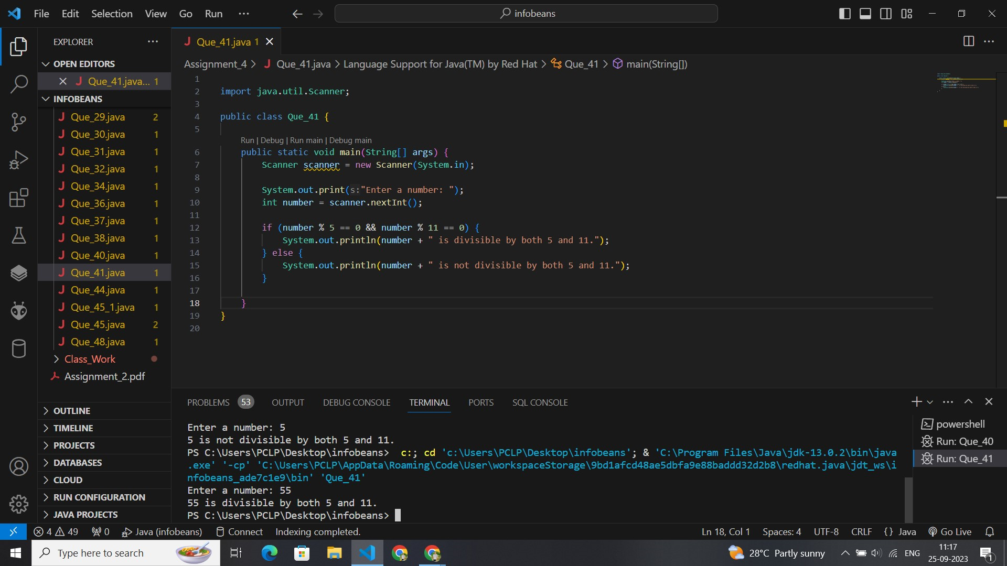

import java.util.Scanner;

public class Que_41 {

    public static void main(String[] args) {

        Scanner scanner = new Scanner(System.in);

        System.out.print("Enter a number: ");

        int number = scanner.nextInt();

        if (number % 5 == 0 && number % 11 == 0) {

            System.out.println(number + " is divisible by both 5 and 11.");

        } else {

            System.out.println(number + " is not divisible by both 5 and 11.");

        }

    }

}

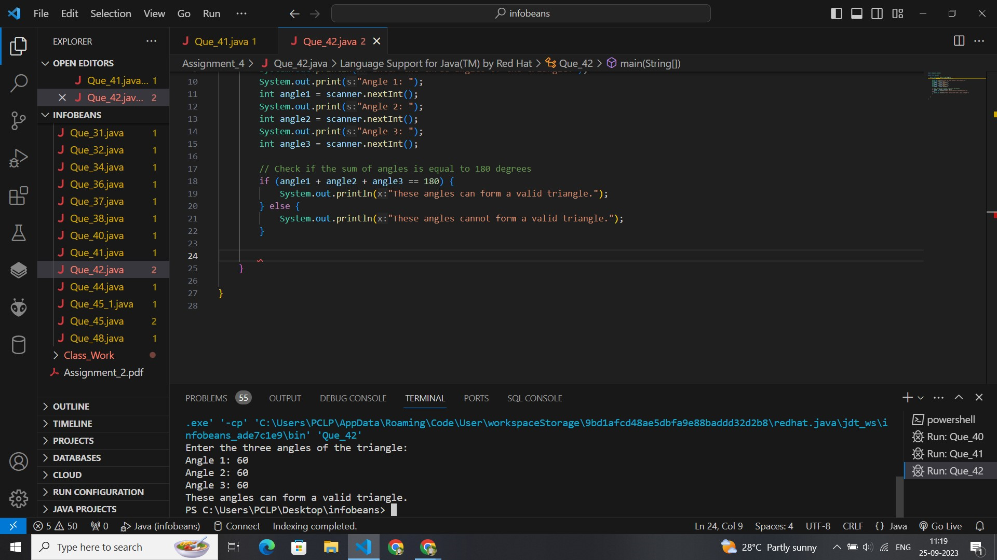

import java.util.Scanner;

public class Que_42 {

    public static void main(String[] args) {

        Scanner scanner = new Scanner(System.in);

        System.out.println("Enter the three angles of the triangle:");

        System.out.print("Angle 1: ");

        int angle1 = scanner.nextInt();

        System.out.print("Angle 2: ");

        int angle2 = scanner.nextInt();

        System.out.print("Angle 3: ");

        int angle3 = scanner.nextInt();

        // Check if the sum of angles is equal to 180 degrees

        if (angle1 + angle2 + angle3 == 180) {

            System.out.println("These angles can form a valid triangle.");

        } else {

            System.out.println("These angles cannot form a valid triangle.");

        }

    }

}

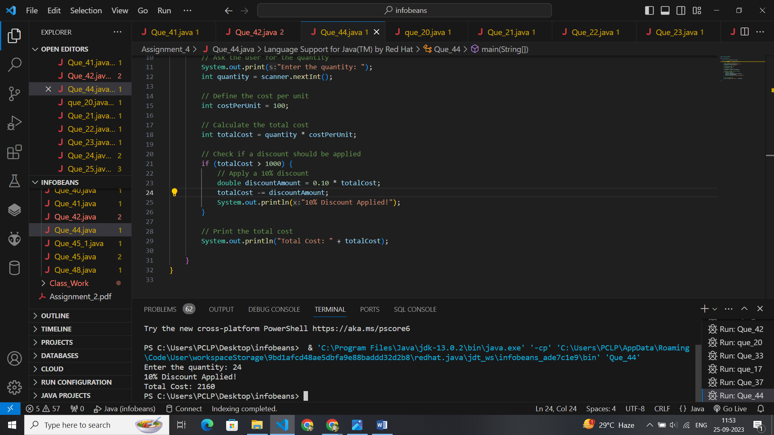

import java.util.Scanner;

public class Que_44 {

    public static void main(String[] args) {

        Scanner scanner = new Scanner(System.in);

        // Ask the user for the quantity

        System.out.print("Enter the quantity: ");

        int quantity = scanner.nextInt();

        // Define the cost per unit

        int costPerUnit = 100;

        // Calculate the total cost

        int totalCost = quantity * costPerUnit;

        // Check if a discount should be applied

        if (totalCost > 1000) {

            // Apply a 10% discount

            double discountAmount = 0.10 * totalCost;

            totalCost -= discountAmount;

            System.out.println("10% Discount Applied!");

        }

        // Print the total cost

        System.out.println("Total Cost: " + totalCost);

    }

}

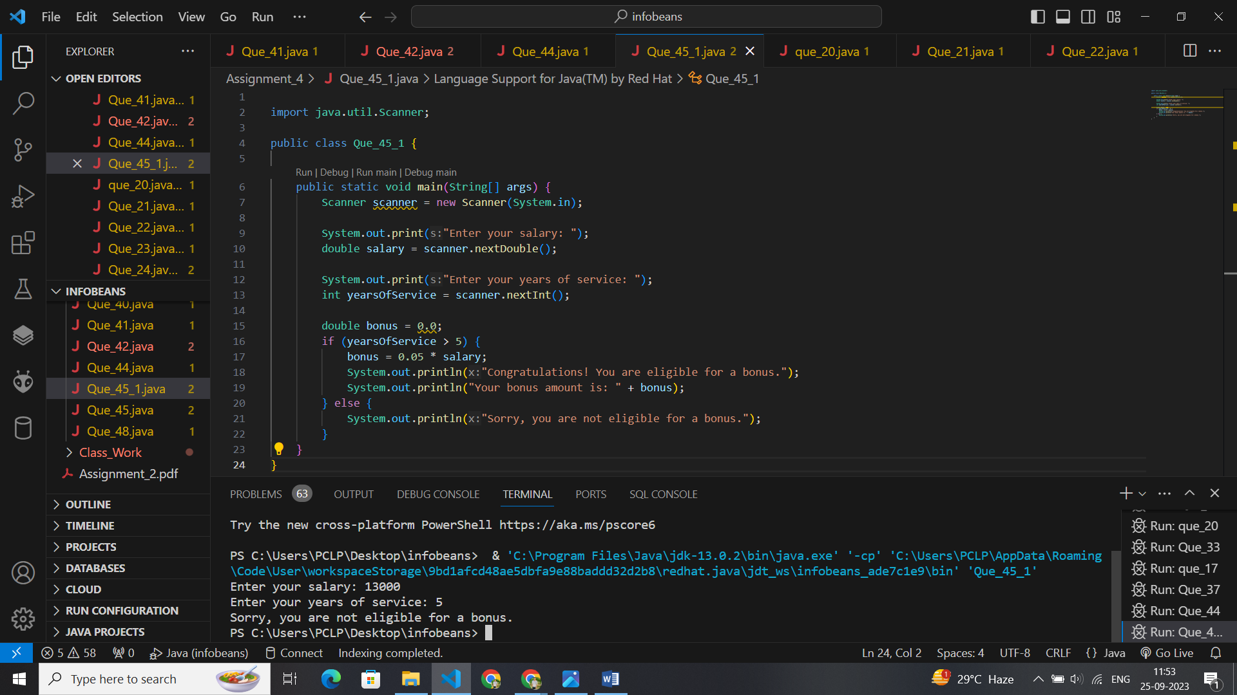

import java.util.Scanner;

public class Que_45_1 {

    public static void main(String[] args) {

        Scanner scanner = new Scanner(System.in);

        System.out.print("Enter your salary: ");

        double salary = scanner.nextDouble();

        System.out.print("Enter your years of service: ");

        int yearsOfService = scanner.nextInt();

        double bonus = 0.0;

        if (yearsOfService > 5) {

            bonus = 0.05 * salary;

            System.out.println("Congratulations! You are eligible for a bonus.");

            System.out.println("Your bonus amount is: " + bonus);

        } else {

            System.out.println("Sorry, you are not eligible for a bonus.");

        }

    }

}

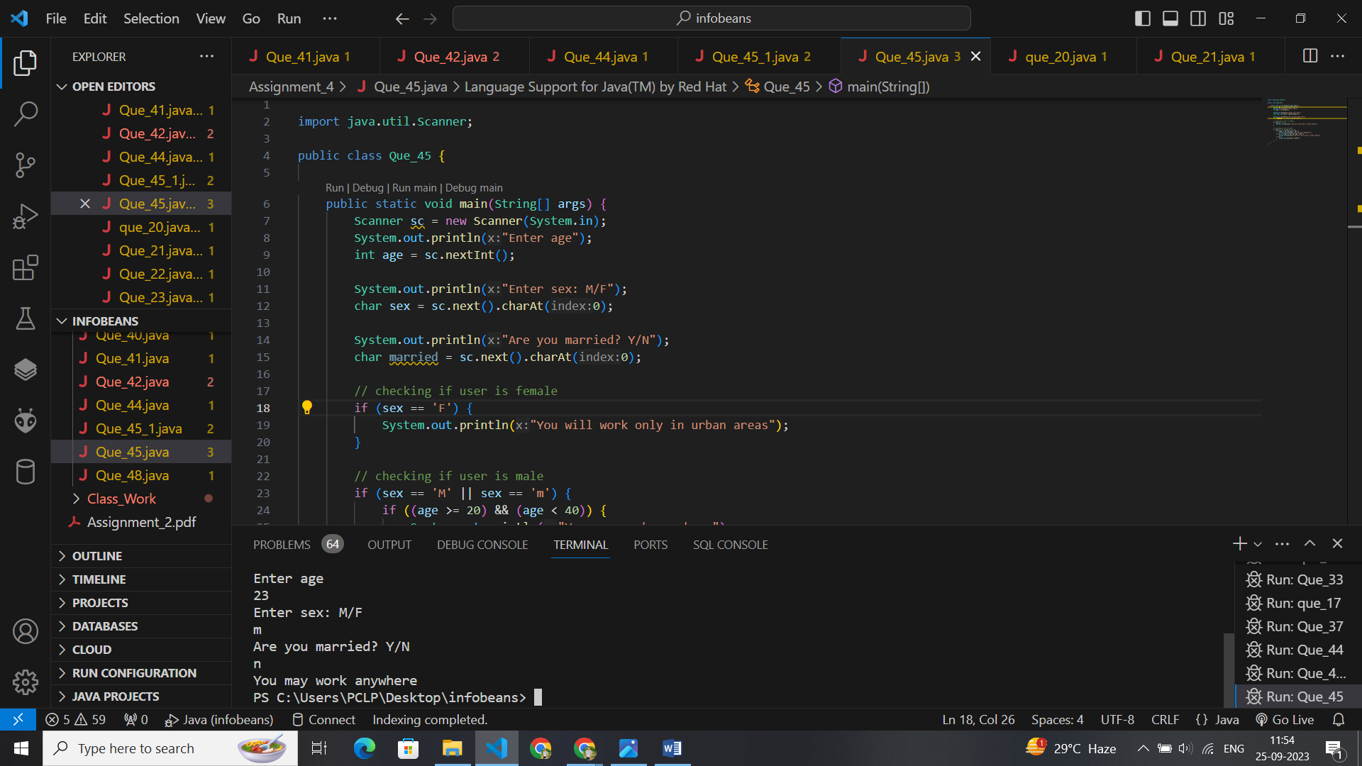

import java.util.Scanner;

public class Que_45 {

    public static void main(String[] args) {

        Scanner sc = new Scanner(System.in);

        System.out.println("Enter age");

        int age = sc.nextInt();

        System.out.println("Enter sex: M/F");

        char sex = sc.next().charAt(0);

        System.out.println("Are you married? Y/N");

        char married = sc.next().charAt(0);

        // checking if user is female

        if (sex == 'F') {

            System.out.println("You will work only in urban areas");

        }

        // checking if user is male

        if (sex == 'M' || sex == 'm') {

            if ((age >= 20) && (age < 40)) {

                System.out.println("You may work anywhere");

            } else if ((age >= 40) && (age < 60)) {

                System.out.println("You will work only in urban areas");

            } else {

                System.out.println("ERROR");

            }

        }

    }

}

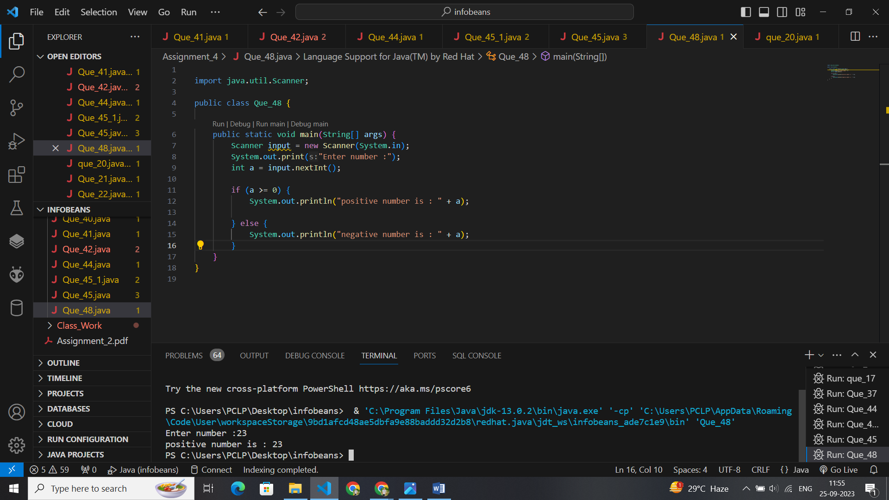

import java.util.Scanner;

public class Que_48 {

    public static void main(String[] args) {

        Scanner input = new Scanner(System.in);

        System.out.print("Enter number :");

        int a = input.nextInt();

        if (a >= 0) {

            System.out.println("positive number is : " + a);

        } else {

            System.out.println("negative number is : " + a);

        }

    }

}